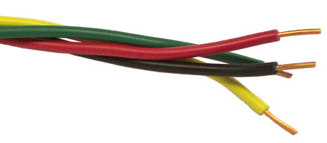
The Wire Award - Evidence Collecting Form
Staff Name
School
For South Glos, Swindon and Bristol Schools
Widening Inclusion in Religious Education
Element | Place / Event / Date | Signature of person / evidence | Role of person/explanation
1. Visiting place of worship
Christian
Other faith/belief
2. Training event (CPD)
3. School based event - entering a competition or putting on an event
For further communication or support please contact katy.staples@bristoldiocese.org (Bristol and Swindon) or laura.harris@bristoldiocese.org (South Glos)

For elements 1 and 3 please submit scanned evidence of 3 pieces of pupil’s work or a link to the school’s website where work can be viewed.
A directory of places of worship within the Bristol area can be found here: http://www.awarenessmysteryvalue.org/2016/g03-resources-visitors-and-local-places-of-worship/
Opportunities for CPD on offer within the area can be found here : https://www.bristol.anglican.org/events/category/training/
https://www.natre.org.uk Spirited Arts or Spirited Poetry is a great National RE Art competition - evidence of entering this (not necessarily winning) is sufficient

