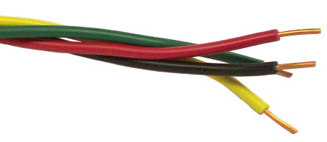

The Gold Wire Project - Evidence Collecting Form
Staff Name
School
For South Glos, Swindon, Wiltshire and Bristol Schools
Widening Inclusion in Religious Education
Element | Place / Event / Date | Signature of person / evidence | Role of person/explanation
1. Engaging with Pupils
2. Engaging with Parents
3. Engaging with other schools or the wider community

4. One more

For further communication or support please contact katy.staples@bristoldiocese.org (Bristol and Swindon) or adam.robertson@bristoldiocese.org (South Glos)

