RSHE Parental Engagement during a time of Covid 19
“All schools must have in place a written policy for Relationships Education and
RSE. Schools must consult parents in developing and reviewing their policy. Schools
should ensure that the policy meets the needs of pupils and parents and reflects the
community they serve.”

“The broad process for engagement should
involve the school providing clear information
to all parents, in an accessible way, on their
proposed programme and policy; parents
being given reasonable time to consider
this information; the school providing
reasonable opportunities for parents to
feed in their views; and the school giving
consideration to those views from parents.
Schools ultimately make the final decisions
and engagement does not amount to a
parental veto”.
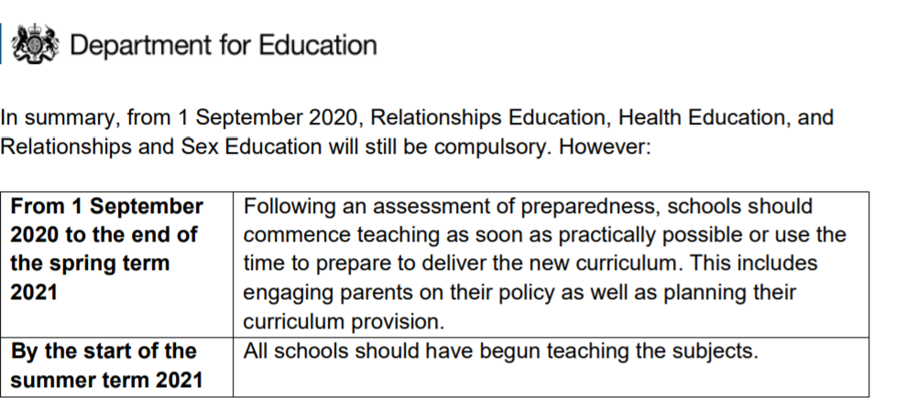

During a “normal” school year parental engagement or consultation meetings about RS(H)E would happen face-to-face and would be part of the fabric of ongoing relationships with parents and carers.
For future years, the ‘subject leader’ tab of the Goodness and Mercy website has supporting materials for parents’ meetings and engagement.
Before any engagement process can start, the Governing body needs to have met, discussed and agreed a draft policy and reviewed the programme of study recommended by the responsible members of staff.
This year’s consultation and engagement will probably, most wisely, be held through electronic means – for example, using the school newsletter, an RSHE-specific letter , an electronic poll (a virtual consultation meeting might be held where appropriate) an agreed e-mail for feedback etc. Then, a meeting of ratification, and a final communication of the decisions made to the parental body. .
Summary of suggested process for parental and community engagement
(under COVID 19 2020/21)
- Governing Body meets to agree draft policy and review programme of study.
- Through the usual vehicles of communication (e.g. newsletter, email communication, website, a virtual consultation meeting where appropriate’ etc.):
- The statutory expectations from the DfE are communicated;
- The draft policy is shared, along with an outline of the proposed curriculum;
- The deadline for responses and comments is clearly communicated and the accepted method of responding is explained (e.g. individually written responses either e-mailed or given in person or the use of an electronic polling tool).
- Senior Staff and Governors review the responses received, consider the feasibility of any possible changes in response to this feedback and decide on the final policy, programme of study and form of communication of the same to the parent body.
- A communication is sent to parents, briefly summarising the responses received and explaining that in the light of that, the final policy and overview of the programmes of study can now be found on the school website.
- A review of the impact of the curriculum offer is carried out and an ongoing rhythm of engagement with parents is agreed (annually / bi-annually) and built into the school’s cycle of improvement.

https://goodnessandmercy.co.uk/wp-content/uploads/2020/07/A4-Relationships_Education__Relationships_and_Sex_Education__RSE__and_Health_Education-16496.pdf
https://assets.publishing.service.gov.uk/government/uploads/system/uploads/attachment_data/file/884450/Parental_engagement_on_relationships_education.pdf
https://www.safeguardinginschools.co.uk/wp-content/uploads/2020/06/Communication-to-schools-on-the-implementation-of-Relationships-Education-Relationships-and-Sex-Education-and-Health-Education-June-2020-1.pdf
https://goodnessandmercy.co.uk/wp-content/uploads/2020/08/B5-Guidance-for-a-governors-meeting.pdf
https://goodnessandmercy.co.uk/subject-leaders/ A sample policy for RSHE can be found here for adaptation.

