**A Month with the Franciscans**

# **Background**

This month, we shall be looking at Franciscan Mysticism. The story of St Francis (1181-1226) and his immediate companions is probably very familiar to you. His renunciation of parental privilege in favour of a life of begging and caring for the poor is taught and celebrated almost universally. If you have seen Zeffirelli’s film ‘Brother Sun and Sister Moon’, it is hard to forget the scene where an overawed Francis and his ragged brothers are ushered into the overwhelming richness of the Pope’s entourage in majestic St Peter’s, only to win over the Pope and receive blessing for their cause of holy poverty. We shall consider aspects of the lives of St Francis and St Clare in week 1, but without the saccharine.

Francis’ instinct for the divine created a legacy of self-less behaviour, but it was left to later Franciscan bothers, St Bonaventure (1221-1274) in Paris and John Duns Scotus (1265-1308) in Oxford, to explain and codify the theological convictions of the early Friars Minor. We shall look at this in week 2.

Franciscans have a distinct “Alternative Orthodoxy” when it comes to issues like Atonement (at-one-ment with God) and death; quite unlike conventional Protestantism. These have significant implications for life and faith, so we shall consider them in week 3.

In the final week, we shall return to self-less action and to life lived as a Franciscan today.

To experience more fully contemporary Franciscan spirituality, we suggest that you experiment using **one** of the Franciscan daily offices, perhaps from Celebrating Common Prayer. To start, try Night Prayer or Midday Prayer for a couple of weeks, depending on your schedule of commitments. Then then switch to, or add in, another of the offices. They differ each day, so follow these links:

* [**Sunday** *Eastertide, feasts of our Lord, Group Commemorations*](https://www.oremus.org/liturgy/ccp/06sun.html)
* [**Monday** *Pentecost, Apostles & Evangelists, Missionaries*](https://www.oremus.org/liturgy/ccp/07mon.html)
* [**Tuesday** *Advent, Religious*](https://www.oremus.org/liturgy/ccp/08tue.html)
* [**Wednesday** *Christmastide, the BVM*](https://www.oremus.org/liturgy/ccp/09wed.html)
* [**Thursday** *Epiphany, Teachers & Confessors, Bishops*](https://www.oremus.org/liturgy/ccp/10thu.html)
* [**Friday** *Lent, Passiontide, Martyrs*](https://www.oremus.org/liturgy/ccp/11fri.html)
* [**Saturday** *Kingdom, any Saint, Commemorating the Departed*](https://www.oremus.org/liturgy/ccp/12sat.html)

# **Week 1 Francis and Claire**

The life of St Francis is well known. His deep experience of God led him to believe firmly in God’s protection and provision. He followed literally the words from Christ to ‘give away possessions’ and to ‘build my church’; his was a day-to-day dependence on God’s provision. He felt a deep connection with nature, as he saw all creatures as alive in the One God. He led by example those attracted to follow him, and emphasised discernment of God’s Will in leading a life prophetic to the world around them. Poverty, prayer, simplicity and detachment characterised that life, together with a particular love for the outcast or underprivileged.

In a session, consider what in that life you admire. Is there anything in Francis’ life that you would like to see more of in your own?

Francis learned to see God in everyone and act accordingly. Hands-on ‘social action’ followed as part of this love for God and his neighbour. Are you attracted to this way of living? How easy do you find it to see something of God in every person? How might you develop this perception?

While still a very devout teenager and betrothed to a wealthy man, St Clare heard Francis preach in Assisi and renounced wealth and marriage to follow in the Franciscan way. Initially living in a Benedictine nunnery, a group of like-minded women gathered around her, becoming known as the ‘Poor Clares’ after her death. Her community was enclosed, engaged in manual work, prayer, poverty and silence (unlike the itinerant male Friars). Their rule of life was set by Francis. Clare reluctantly became leader of both male and female Franciscans at Francis’ request, and apparently led with a self-less shyness and devotion. She nursed Francis during his final illness and death. She was a radical leader in incorporating women (into the Second Order) and lay people (into the Third Order). Do you think that there is a place for such radicalism today? If so, in which areas of church life?

Under Clare, the Friars Minor grew, but the extremes of deprivation of the life of the sisters became a Papal concern. Clare’s response apparently, was "Holy Father, never and in no way do I wish to be dispensed from following Christ!".How does such an attitude make you feel?

Richard Rohr OFM says (in a lecture) that:

‘…what Francis discovered and gave the Franciscan tradition was a very lovable, likable God that was easy to draw near to… and you see it in his writings, and in the writings of Clare too: they didn't fall in love with the divinity of Christ, they fell in love with the humanity, that he was just so humble, and human, and sweet, and non-punitive, and inclusive.’

Is that your image of God? Can you appreciate how attractive that might be to people with no faith today?

# **Week 2 Bonaventure & Duns Scotus**

In the thirteenth century, some half a century after Francis’ death, both Bonaventure and Duns Scotus made considerable contributions to understanding God through a Franciscan lens. The basis of their world view was very different from today. It was generally accepted that creation was ordered as a *‘*Great Chain of Being’ (see below) where spirituality declined down the chain from angels, through mankind to plants. Bonaventure discerned that all creation bore the fingerprints and footprints of our infinite God, whose ‘centre is everywhere and whose circumference is nowhere’. Duns Scotus discerned that as all of creation participates in the same Being (God’s Being) to various extents, so humans speak with one voice with creation (‘Univocicity of Being’). We are connected to creation and all is sacred.

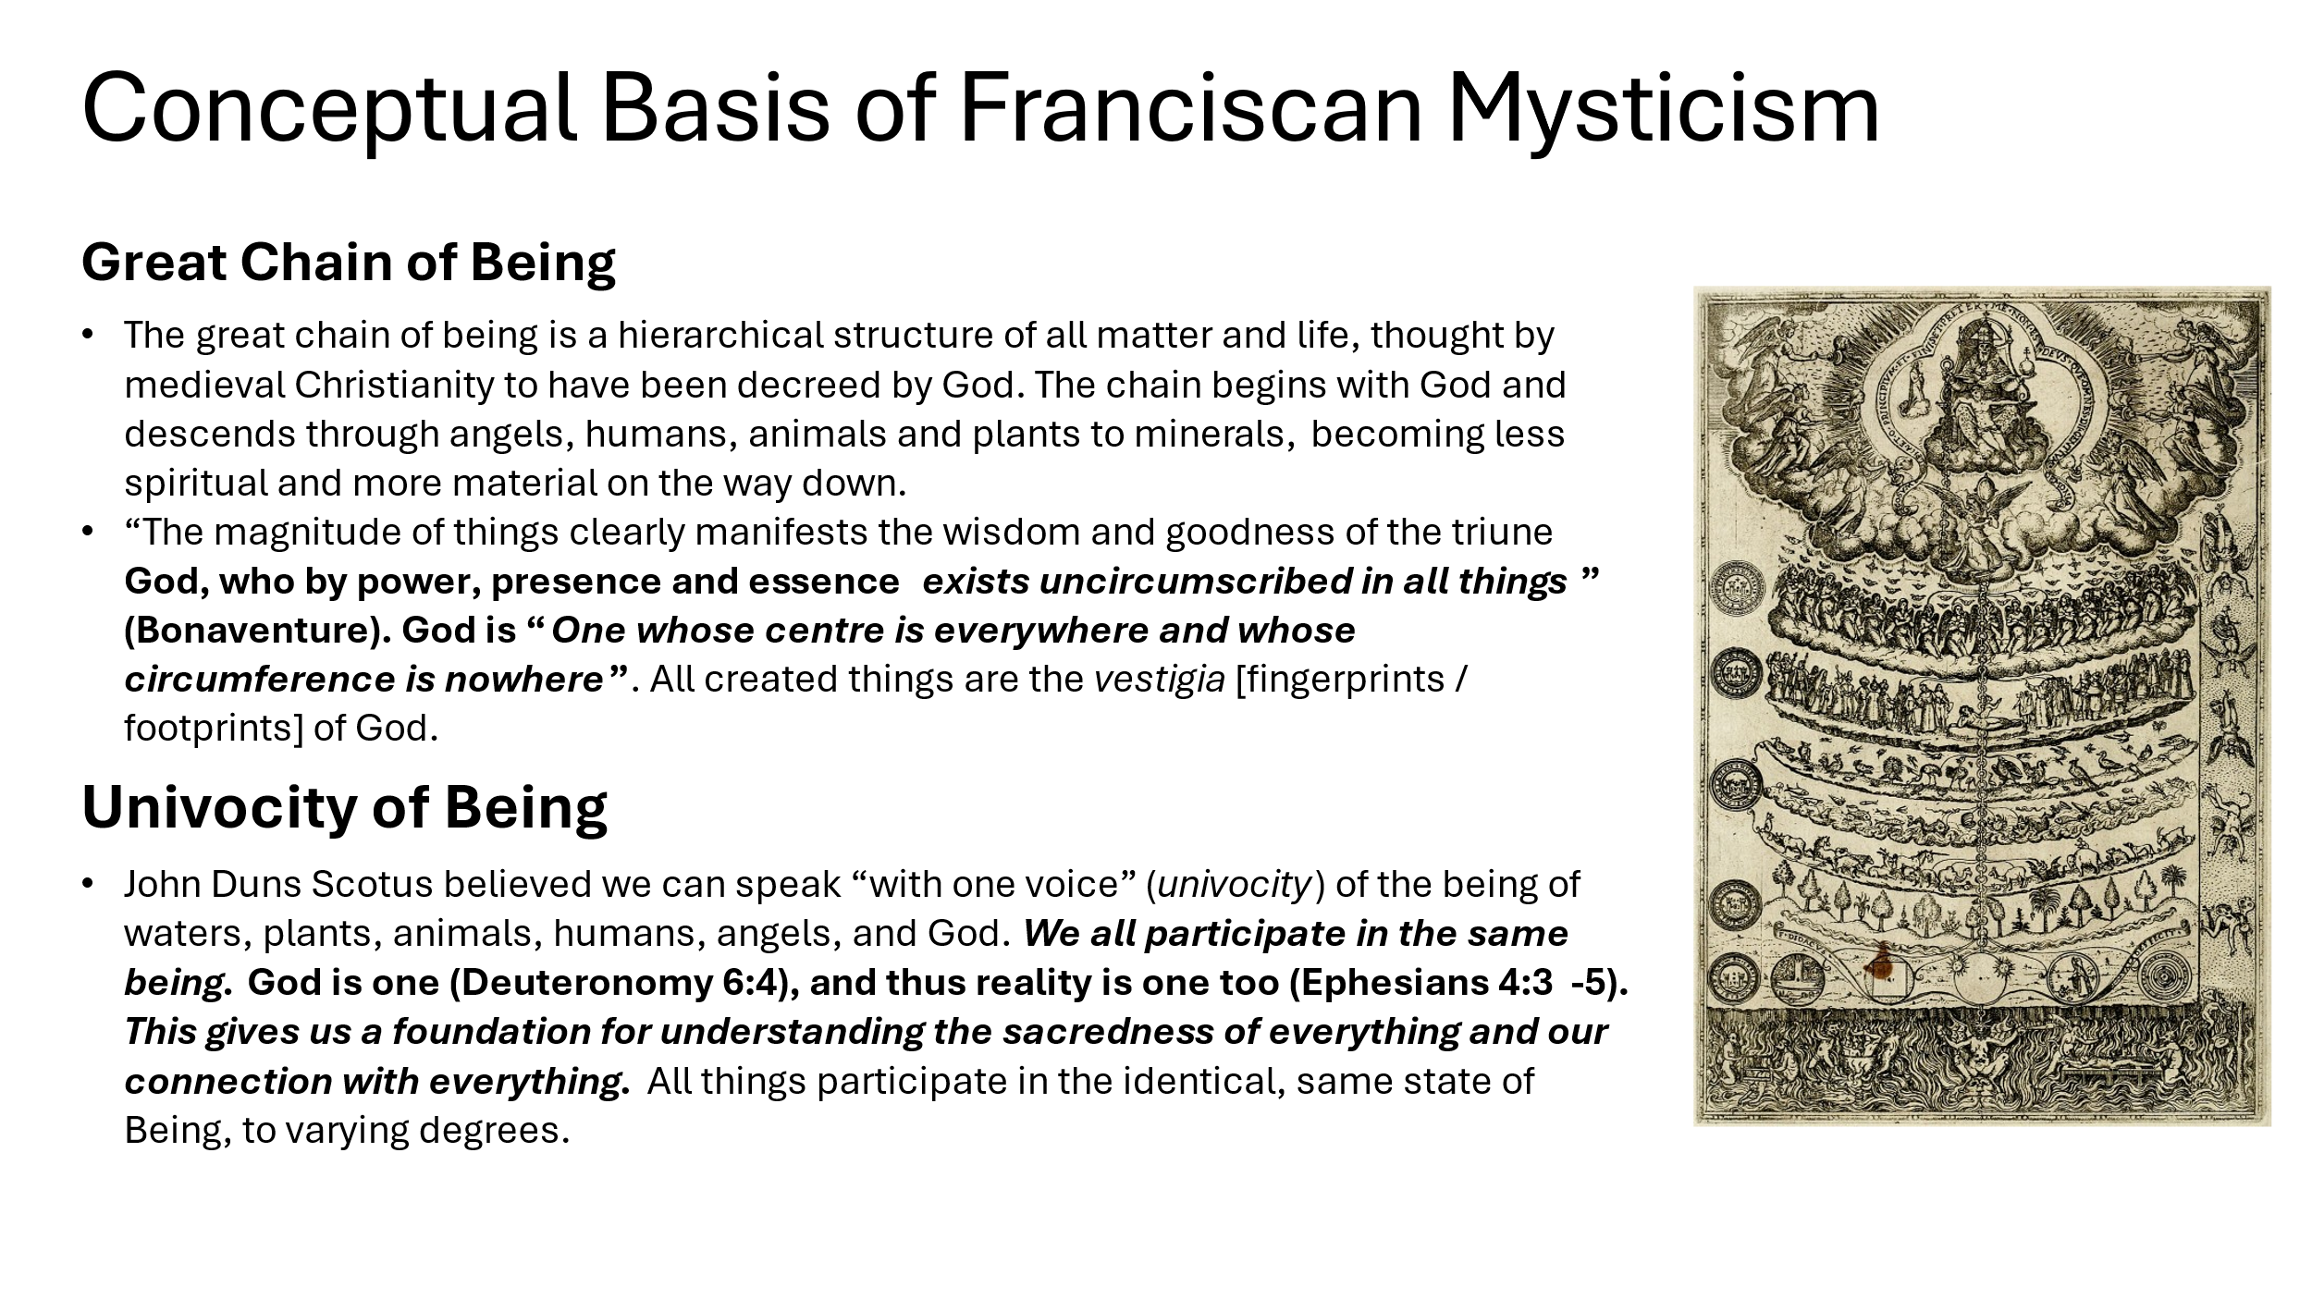

Spend a session simply pondering this world view and its implications.

In another session, contemplate a God whose ‘centre is everywhere and whose circumference is nowhere’. Put simply, God fills the Universe and beyond it. That must mean God fills you too. Are you comfortable with those thoughts?

Separately, think of the implications of God’s fingerprints are all over his creation, as his Being fills creation. How then will *you* treat created things, suffused by God’s Being?

Ponder in a session Duns Scotus’ view that we all participate in the same being as God and Creation. How then will you treat your fellow human beings? Is your answer affected at all if they hold a different set of beliefs to you, or none at all?

“The Incarnation of God did not happen in Bethlehem 2000 years ago. That is just when we started taking it seriously. The incarnation actually happened 14.5 billion years ago with a moment that we now call “The Big Bang.” That is when God actually decided to materialize and to self expose. Two thousand years ago was the human incarnation of God in Jesus, but before that there was the first and original incarnation through light, water, land, sun, moon, stars, plants, trees, fruit, birds, serpents, cattle, fish, and “every kind of wild beast” according to our own creation story (Genesis 1:3-25). This was the “Cosmic Christ” through which God has “let us know the mystery of his purpose, the hidden plan he so kindly made from the beginning in Christ” (Ephesians 1:9).” (Richard Rohr OFM).

How do you react to this concept? Some say that ‘Creation was the first Bible’; what are the implications of that for you?

# **Week 3 The First Idea in the Mind of God**

Conventional wisdom in medieval times was that Jesus died to ‘pay the price’ for human sin either to ‘the Devil’ or to God (as argued in C11 by St. Anselm of Canterbury). John Duns Scotus objected to such atonement images, mainly as they were inconsistent with a compassionate God. He said that *“*Christ was the first idea in the mind of God*”* (building on the ‘Cosmic Christ’ of Colossians, Ephesians, John’s Gospel prologue and the intuitions of St Francis). Jesus came to reveal God’s plan for humankind and to model perfect human life; Jesus was God’s Masterpiece. That was always ‘plan A’. Jesus did not come as ‘plan B’, a response to humankind’s sinfulness. Jesus was not a ‘blood sacrifice’ to change God’s attitude to humans; Jesus was revealing a God of absolute unconditional love. In modern terms, God was not blind-sided by human sin and forced into ‘plan B’. What we think of as ‘Atonement’ was simply unnecessary as God’s compassionate love is unconditional. Duns Scotus created controversy at the time, and the term “Dunce” was coined (a shortening of his name) to belittle his scholarship.

In a session, consider how hard it is for Protestants brought up with a Sin-Fall-Atonement model to come to terms with such thinking. Is it hard for you to do so? Now consider the view that we all share in God’s Being; is the Sin-Fall-Atonement model inconsistent with that? As your brain will be overloaded by now, leave any conclusions to tomorrow!

The big question for this session is: how do you now see atonement? Are you comfortable with the image of God that that view requires?

St Francis referred to death as *‘*Sister Death’, a friend, nothing to be afraid of. This is consistent with his view of a compassionate God who raised Jesus from death, and can be trusted with our own lives. Such an assurance is given many times in the NT, not least in 1 Cor. 15 v51-55, *“*Death has been swallowed up in victory”. Consider how this friendship with death makes you feel.

The contemporary Franciscan author Richard Rohr refers to ‘four splits’ in the human condition: self from other selves; life from death; mind from body and acceptable from unacceptable self. Each serve to isolate us as individuals. In the process of our lives and of our dying, these splits are reversed (in the reverse order) to bring us to eternal union with God. They are reversed by: No idealising of your Self; realising that words are not reality; ‘diving ‘into poverty; and loving your neighbour as you love your Self.

Consider this, including the figure below, in a session.

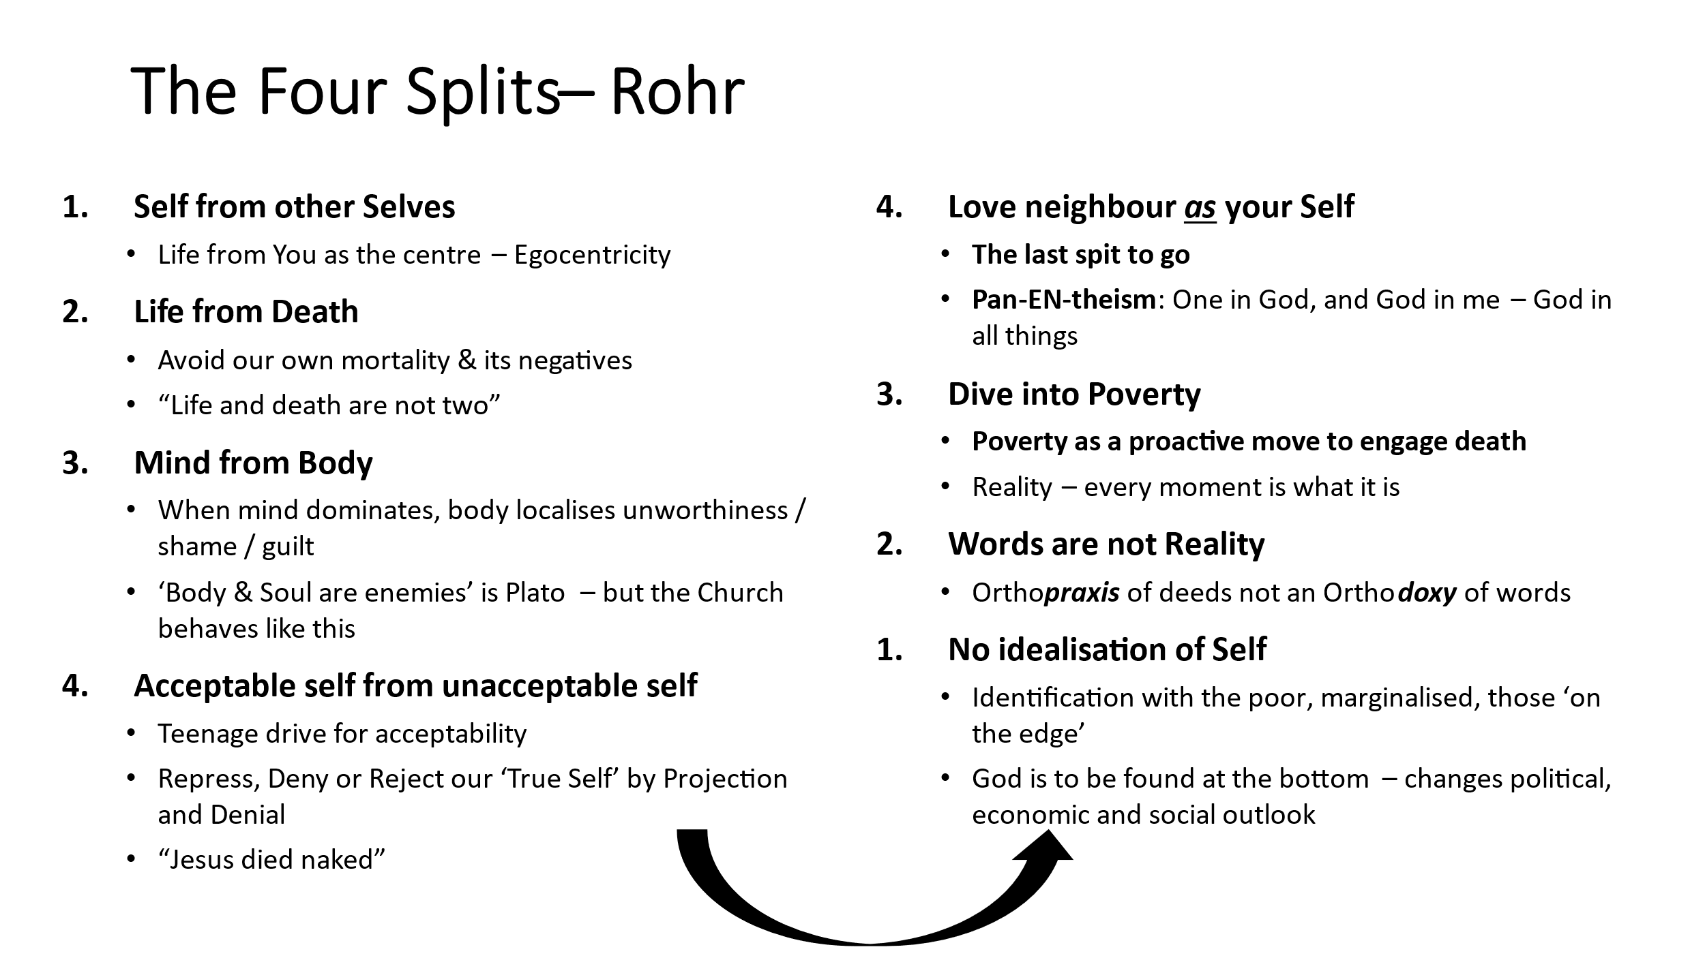

Knowing that dying brings union with God in eternity, is it easier for you to be on friendly terms with death as ‘Sister Death’?

# **Week 4 Self-less Action**

In the midst of the fighting of a Crusade, Francis sent two friars to the Holy Land in 1217. He himself visited two years later and was received with some honour by Sultan Meleck el Kamel, gaining the respect of the Muslims. It was agreed that his Order of Brothers could live among them, teaching a Gospel of universal brotherhood under God and theological tolerance; and living a life of service to all human beings without racial or religious distinctions. The Franciscan way of reconciliation still seems to be accepted and admired in unexpected places. How might our church learn from this today?

Read 2 Corinthians 5 v17-20. Now list the issues locally where reconciliation would be beneficial. Do you feel drawn into a ministry of reconciliation locally?

Like Jesus before him, St Francis ministered to the poor and disadvantaged. That tradition remains strong in the Franciscan orders. Spend a session prayerfully looking at the websites below. Are you drawn to take any particular action?

[Hilfield Home - New Hilfield Website (hilfieldfriary.org.uk)](https://www.hilfieldfriary.org.uk/)

[Order of Friars Minor in Great Britain](https://www.friar.org/)

[Home (anglicanfranciscans.org)](https://anglicanfranciscans.org/)

[Home Page - Franciscans](https://www.franciscans.org.uk/)

Finally, review this month’s activity. What attracted you most? What did you find most difficult? How will you take this forward, if at all.

# **Follow-up Resources**

* Br. Ramon (1994) *Franciscan Spirituality* SPCK
* Br. Ramon *A Month with St Francis* SPCK
* Cocksedge S et al (2021) *Seeing Differently: Franciscans and Creation*. Canterbury Press
* Short WJ (1999) *Poverty and Joy: The Franciscan Tradition.* DLT
* Cocksedge S (2010) *Francis of Assisi* Grove Spirituality #115
* Rohr R (2014) *Eager to Love*  Franciscan Media
* <https://cac.org/>

Iab/2/10/24 VF