What should we know? | Connections (using images) | What should we be able to do?
- That sex is good, God given, and can give joy to life. (Ethos)  - That Sex can in some contexts cause anxiety and pain; it can become an addictive driver of actions, it can also be used as a manipulative tool and cause harm. In order for sex to bring Life and Joy good boundaries and rules are wise.  - The concepts of and laws relating to, sexual consent, sexual exploitation, abuse, grooming, coercion, harassment, rape. Domestic abuse, honour-based violence and FGM, how these can affect current and future relationships.  - What constitutes sexual harassment and sexual violence and why these are always unacceptable (give reference to Equalities Law 2010 - Citizenship)  That some types of behaviour within relationships are criminal (Citizenship).  - How people can actively communicate and recognise consent from others, including sexual consent, and how and when consent can be withdrawn (in all contexts including online)  - Specifically sexually explicit material e.g. pornography presents a distorted picture of sexual behaviours. It can damage the way people see themselves in relation to others and negatively affect how they behave towards sexual partners.  - That sharing and viewing indecent images of children (including those created by children or young people) is a criminal offence which carries severe penalties including jail (Citizenship - Law)  - How information and data is generated, collected, shared and used online, in order to keep ourselves safe.(safeguarding)  - How STIs are spread and how risks can be reduced through safer sex and the importance of and facts around testing  - About reproductive health, including fertility, the facts around pregnancy, including the choices surrounding pregnancy, miscarriage, and where to get help.  - How the use of alcohol and drugs can lead to risky sexual behaviour | 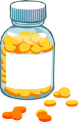      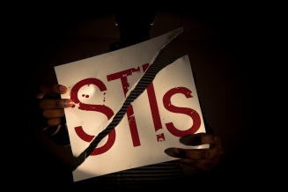    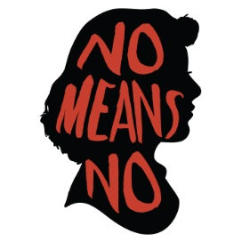  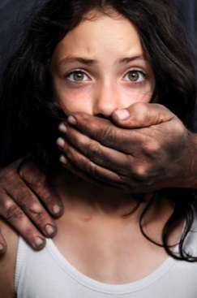    Alcohol and drugs and risky sexual choices ?  Fertility, Pregnancy and choices  Knowing about and preventing sexually transmitted Infections  Sexual Consent  The use and impact of pornography  UK Laws and Sexual misconduct  And God saw that it was good | - Give reasons for the school’s positive beliefs around sex and good boundaries, evaluate those beliefs and explain your own beliefs surrounding sex and good boundaries.  - Explain the ways in which sex can cause harm and outline the laws surrounding sexual exploitation etc Explain which behaviours are unacceptable and unlawful and why.  - Describe what consent is, how it can be communicated well, and how to recognise it. Explain how and when it can be withdrawn in all contexts(including online)  - Explain what pornography is and the forms it can take. Describe how it can give a distorted picture of sexual behaviours and appearance. Explain why some people enjoy pornography and how it might affect how they behave towards their sexual partner.  - Explain the Law and severe penalties surrounding the sharing of indecent images of children. Describe how data is generated, collected and shared online and explain how that can affect us  - List the different Sexually transmitted diseases that exist and how they can affect health (including fertility). Explain how we can reduce the transmission of these diseases; how people can practice safe sex and how testing works.  - Explain why the use of alcohol or drugs can lead to risky sexual behaviour  - Talk about reproductive health and pregnancy. Describe what happens in pregnancy ( and the possibility and frequency of miscarriage)Describe the choices surrounding pregnancy (keeping the baby, adoption, abortion). Know where someone can go to get help.  - Discuss and evaluate different religious and non-religious beliefs surrounding pregnancy, and the options available (particularly in regard to abortion). (RE)
What words should we understand and be able to use.
Vocabulary | Definition
Sexual consent | To permit, approve or agree to Sex
Sexual Exploitation | To sexually utilise or “use” someone , especially for profit
Coercion | Using force or intimidation to obtain compliance (or agreement)
Grooming | To befriend and establish emotional connection with someone , to lower their inhibitions with the objective of sexual abuse
Rape | Unlawful sexual intercourse or any other sexual penetration, with or without force ,by a sex organ, or foreign object, without the consent of the victim.
Sexual Harassment | The act of an instance of disturbing, pestering or troubling a person persistently for sex
Honour-based violence | This is a crime or incident which has or may have been committed to protect or defend the honour of the family and/or community
FGM (Female Genital Mutilation) | This is also known as female genital cutting and female circumcision. It is the ritual cutting or removal of some or all or the external female genitalia. It is recognised internationally as a violation of the human rights of girls and women. It is illegal in the UK.
Pornography | Sexually explicit videos, photographs, writings , or the like, whose purpose is to elicit sexual arousal
STIs (Sexually Transmitted Infections) | Any infection that is characteristically transmitted by sexual contact and may clear up or develop into a sexually transmitted disease.
Fertility | The state or ability to produce offspring; the power to of reproduction
Pregnancy | The state or quality of having an offspring developing in the body
Miscarriage | The expulsion of a foetus before it is viable (usually between the third and sixth months of pregnancy)
Theological Vocabulary | Definition
Created | Our School believes that we have been created and are carefully made.  As image bearers of God we too, sometimes, are privileged to create life and have responsibility for the nurture of new life as parents.
Dignity | Our school believes that we need to see ourselves and treat others with huge respect as people who are crafted by God.
Worthy | Having great value .We are all worthy of looking after and protecting, as are all people  .We are not “consumers” of others and we should not seek to make others or ourselves into “commodities”
Community | We are a part of a group and in our relationships we need to realise we can have an impact on others. We need to try to show kindness and help everyone feel happy and safe. Jesus taught “Love your Neighbour as yourself” Matthew 22. 37 - 39
Wisdom | Knowing what is true or right and discerning through insight what are good actions. Understanding how one might be “played” and making loving choices. Knowing when to Love oneself enough to walk away from someone who is harmful and untrustworthy.
Frail (Fallen) | People are inclined to make poor choices for their own well being, and the well being of others, this is part of being human.
Forgiveness | We can start again, if we recognise our bad choices and start afresh. Christians believe God can help you live with more care for yourself or others
Faithful | Staying true to someone and sticking by them, being loyal and constant even when it is tricky, unless to do so would harm yourself or another.

