What should we know? | Connections (using images) | What should we be able to do ?
- That there are families that are not biological that can offer support and love : the school as family , the church as family, the community as family  - The roles and responsibilities of parents , what it means to raise children and be faithful caring parents  - The characteristics of positive healthy friendships  in all contexts , (including online) : trust , honesty, kindness, generosity, boundaries ,consent , managing of conflict, forgiveness , reconciliation , ending relationships and living with loss  - The positive steps that can be taken to improve or support respectful relationships  - That some types of behaviour within relationships are criminal, including violent behaviour and coercive control. |     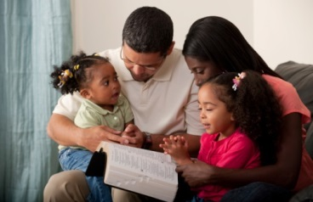  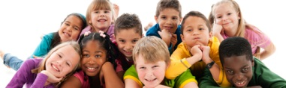  Creating good boundaries  Healthy Friendships  Parenting: joys and challenges  Defining and analysing many scales and types of family | - Talk about the difference between biological families or families as people who you live with, and the way someone can experience and create families through life. “Family “as a strong and meaningful metaphor for connection, care and responsibility to others: The family of a tutor group, school, of God/ Church/Humankind, a neighbourhood or a group of friends.  - Explain the responsibilities of parenthood - what it entails, why it can be joyous and difficult. Define what categorises faithful and caring parenting.  - Analyse what creates and maintains good friendships (including online). Describe the positive qualities, and steps that can be taken, that help to improve and support relationships.  - Explain the importance of having good boundaries, having strategies for managing conflict and for working towards reconciliation. Describe contexts where it might be best to end a relationship. Talk through how it feels to lose a friend and how to live with loss.  - List types of behaviour within relationships that are criminal, including violent behaviour or use coercive control. How to report crime and seek help in those contexts.

What words should we understand and be able to use.
Vocabulary | Definition
Family | “A social group of parents, children, and sometimes grandparents, uncles, aunts, and others who are related,” Another definition is "Two or more people who share goals and values, have long-term commitments to one another and reside usually, but not always, in the same dwelling.”
Parenthood | The state of being a parent and the responsibilities involved.
Boundaries | A Limiting or bounding line: rules or limits that a person creates to identify reasonable, safe and permissible ways for other people to behave towards them and how they will respond when someone passes those limits
Reconciliation | A situation in which two people or groups of people become friendly again after they have argued.
Bereavement | A period of mourning after a loss, especially after the death of a loved one  Or a state of intense grief, as after the loss of a loved one; desolation.
Coercive control | Is an act or a pattern of acts of assault, threats, humiliation and intimidation or other abuse that is used to harm, punish, or frighten a victim.
Theological Vocabulary | Definition
Created | Our School believes that we have been created and are carefully made
Dignity | Our school believes that we need to see ourselves and treat others with huge respect as people who are crafted by God.
Worthy | Having great value .We are all worthy of looking after and protecting.
Community | We are a part of a group and in our relationships we need to realise we can have an impact on others. We need to try to show kindness and help everyone feel happy and safe. Jesus taught “Love your Neighbour as yourself” Matthew 22. 37 - 39
Wisdom | Knowing what is true or right and discerning through insight what are good actions. Understanding how one might be “played” and making loving choices. Knowing when to Love oneself enough to walk away from someone who is harmful and untrustworthy.
Frail (Fallen) | People are inclined to make poor choices for their own well being, and the well being of others, this is part of being human.
Forgiveness | We can start again, if we recognise our bad choices and start afresh. Christians believe God can help you live with more care for yourself or others
Faithful | Staying true to someone and sticking by them , being loyal and constant even when it is tricky, unless to do so would harm yourself or another.

