What should we know? | Connections (using images) | What should we be able to do ?
- That our school believes we are fearfully and wonderfully made, that God made sex to bring Life and wellbeing. Sex can be a good and fulfilling aspect of life. (Ethos)  - How the media can distort how we see ourselves and cause us to regard ourselves negatively or insufficiently attractive to be desirable and so diminishes our self-esteem. (media/ mental health and wellbeing)  - How to protect ourselves online including from sharing material or viewing harmful content. (safeguarding/media)  - How to recognise the characteristics and the positive aspects of healthy one-to-one intimate relationships, which include mutual respect, a spiritually careful noticing of the other, consent, loyalty , trust, shared beliefs, values, interests and outlook, sex and friendship.  - That many people believe that the best place to raise children is within healthy one- to -one intimate relationships  - That the choices we make in sex and relationships can affect our mental, physical and emotional health either positively or negatively  - How to understand, identify and manage peer pressure around sex. How to resist peer pressure and not pressurise others.  - That we have a choice to delay sex or to enjoy intimacy without sex. That for some people they may wish to only have sex within marriage and that for some people sex is not something they want for themselves. (RE)  - The facts about the full range of contraceptive choices, efficacy and the options available.  - Where to go to get support or to report a concern |         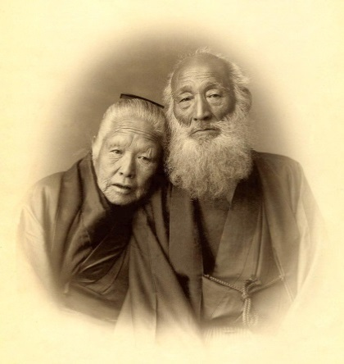  Peer Pressure  Media, advertising and self esteem  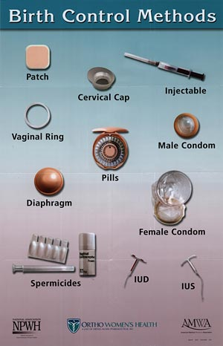    Contraception  The impact of sexual choices  Sharing materials and avoiding harmful content  Long term healthy intimacy  And God saw that it was good | - Explain the school’s beliefs surrounding sex (Ethos).  - Give examples of how the media and advertising can create a context where it is hard to feel attractive and have good self esteem. Describe some strategies, beliefs, campaigns or role models that you can use to counter competitively unrealistic images. (media/ mental health and wellbeing)  - Explain the pitfalls surrounding sharing materials and images online. Explain how someone can ensure they can protect themselves from viewing harmful content. (safeguarding/ media)  - Describe the characteristics of a long-term positive and healthy intimate relationship. What are the factors that mean that an intimate relationship is most likely to last over time? Why might this be the best context for deciding to raise children?  - Explain how both negative and positive choices we make around sex can affect our mental physical, emotional, spiritual and financial wellbeing.  - Give examples of how peer pressure can operate in regard to speaking about sex. Explain why people might want to pressure their peers. Describe strategies for handling peer pressure.  - Talk about why delaying sexual activity might be a wise choice. Explain why some people believe it is right to wait for marriage to have sex and some people may choose to abstain from ever having sex as a positive choice. (RE)  - Explain what contraception is and the facts concerning the full range of contraceptive choices - explain how they work, what they prevent, whose responsibility it is, and how effective they are. (RE - not all people believe contraception is God’s highest will for humanity).  - Tell someone else where they can go for support or to report a concern

What words should we understand and be able to use.

Vocabulary | Definition
Self-esteem | A realistic respect or favourable impression of oneself ; self respect
Sexual Intercourse | Genital contact ( heterosexual - the insertion of the penis into the vagina) followed by orgasm
Orgasm | The physical and emotional sensation experienced at the peak of sexual excitement, usually resulting from the stimulation of sexual organs. (The clitoris, breasts, labia and vagina in the female, the penis and testes in the male). In the male it is usually accompanied by ejaculation.
Ejaculation | The discharge of semen by the penis.
Contraception | The deliberate prevention of conception (pregnancy) by using birth control (there are several drugs or devices)
Peer-pressure | Social pressure by members of one’s peer group to take a certain action, adopt certain values, or otherwise confirm in order to be accepted

Theological Vocabulary | Definition
Created | Our School believes that we have been created and are carefully made
Dignity | Our school believes that we need to see ourselves and treat others with huge respect as people who are crafted by God.
Worthy | Having great value .We are all worthy of looking after and protecting.
Community | We are a part of a group and in our relationships we need to realise we can have an impact on others. We need to try to show kindness and help everyone feel happy and safe. Jesus taught “Love your Neighbour as yourself” Matthew 22. 37 - 39
Wisdom | Knowing what is true or right and discerning through insight what are good actions. Understanding how one might be “played” and making loving choices. Knowing when to Love oneself enough to walk away from someone who is harmful and untrustworthy.
Frail (Fallen) | People are inclined to make poor choices for their own well being, and the well being of others, this is part of being human.
Forgiveness | We can start again, if we recognise our bad choices and start afresh. Christians believe God can help you live with more care for yourself or others
Faithful | Staying true to someone and sticking by them , being loyal and constant even when it is tricky, unless to do so would harm yourself or another.

