What should we know? | Connections (using images) | What should we be able to do?
- How to talk accurately about our emotions using appropriate vocabulary  - The importance of being connected to others and helping them  - How to spot the early signs of mental ill health in ourselves and others  - When something is good for us and when it is having a negative impact on our health  - The benefits of exercise, time spent outdoors and good quality sleep  - That the internet and media advertising can lie and show us only a perfect world that can make us feel inadequate and pressure us into false self portrayal and self disappointment  - There are dangers in online relationships , online gambling and coercive advertising  - Physical fitness and healthy eating can combat stress and disease  - That prayer, meditation and spiritual practices will serve to alleviate stress and increase wellbeing and purpose  - The facts about legal and illegal drugs and alcohol and smoking and the laws surrounding them  - The consequences of addiction to legal and illegal substances  - About personal hygiene, dental health, regular dental check ups and the benefits of regular self- examination and screening ,immunisation and vaccination  - Basic first aid for common injuries and how to administer CPR (Yr9 upwards)and the purpose of defibrillators  - About changing adolescent bodies and the implications for emotional and physical health including menstrual wellbeing | Exercise , healthy eating and good sleep  Nurturing mental wellbeing  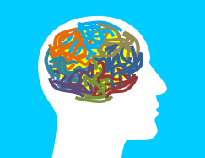  Healthy futures: prevention and first aid  Changing bodies  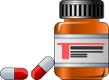  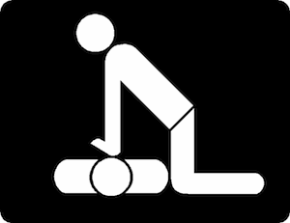  Dangerous substances?      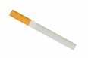  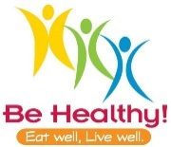  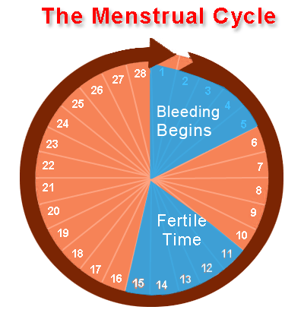  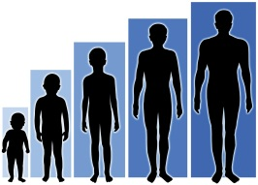  Wise choices online | - I can talk sensitively and accurately about my emotions  - I can understand my connections with others and be aware of my own and their mental well being  - Describe spiritual practices that will help people’s wellbeing  - Make good choices about exercise, food , good sleep patterns and helping others  - Have the wisdom to navigate the internet and social media to protect myself and ensure my mental wellbeing  - Explain how certain substances can lead to addiction and the law surrounding tobacco, alcohol, and drugs.  - Administer basic first aid (and know how to administer CPR - Yr 9 onwards)  - Explain how bodies change at adolescence and how this can effect people physically and emotionally.  - Explain what menstruation is and how girls can be affected by this  - Approach an appropriate person to ask for further support or advice.
What words should we understand and be able to use.
Vocabulary | Definition
Bullying | Behaviour that treats someone or makes someone else feel as if they are worth less than others
Puberty | The time in a person’s life when their body changes to allow them to be able to reproduce and the impact this can have physically and emotionally.
Menstruation | The periodic discharge of blood and mucosal tissue from the uterus occurring approximately monthly from puberty to menopause in non-pregnant women
Addiction | The state of being enslaved to a habit or practice that is psychologically or physically habit-forming (such as to alcohol, drugs or smoking) to such an extent that stopping causes trauma.
Coercive advertising | Targeted advertising based on browser interest , that uses your interests to persuade you to buy in a way that may make you feel compelled: without that product you will be less attractive/ acceptable/ lovable.
Immunization | The process by which someone is made protected from a disease (often through inoculation)
Vaccination | The delivery method by which someone becomes immune against a specific disease and then is extremely unlikely to contract that illness. Eg droplet in the mouth (sometimes administered on a sugar cube) , tablets, or an injection.
CPR (cardiopulmonary resuscitation) | Emergency procedure for reviving heart and lung function, involving special physical techniques and often the use of electrical and mechanical equipment
Theological Vocabulary | Definition
Created | Our School believes that we have been created and are carefully made
Dignity | Our school believes that we need to see ourselves and treat others with huge respect as people who are crafted by God.
Worthy | Having great value .We are all worthy of looking after and protecting.
Community | We are a part of a group and in our relationships we need to realise we can have an impact on others. We need to try to show kindness and help everyone feel happy and safe. Jesus taught “Love your Neighbour as yourself” Matthew 22. 37 - 39
Wisdom | Knowing what is true or right and discerning through insight what are good actions. Understanding how one might be “played” and making loving choices. Referring to Biblical insights and the example of Jesus.
Frail (Fallen) | People are inclined to make poor choices for their own well being, this is part of being human
Forgiveness | We can start again, if we recognise our bad choices and start afresh. Christians believe God can help you live with more care for yourself or others

