What should we know? | Connections (using images) | What should we be able to do?
- That through the love care and nurturing of those we live with many people are given the security of the gift of family.  - That there are many different types of happy caring families where children have good childhoods  - That marriage is a formal and legal commitment which is intended to be lifelong  - That relationships can bring us joy and they give us meaning. They are good for us, through our relationships we learn who we are and how to be less selfish and think of others  - That for most Christians and people of other faiths and beliefs there is often a special ceremony of promises and rituals to mark marriage.  - If our families or those we live with are making us unhappy or uncomfortable we know where to seek advice and how to ask for help  - What the characteristics of good friendship are  - That it is good to be kind in our friendships and not leave people out and feeling lonely  - That friendships have ups and downs and we can learn from these but it is never right to be violent  - How to know who to trust in our relationships and to work out what to do when we are uncomfortable or unhappy - how to solve conflicts and how to seek help.  - That there are different types of bullying, and reasons why people bully others.  - How to not be a bystander and get help.  - How we can protect ourselves and others from bullying  - What stereotypes are and how they can be unfair and hurt people  - The importance of permission seeking and giving in friendships  - How to create safe boundaries around our bodies: knowing what is private and public and what is appropriate and inappropriate contact is.  - We will know how to recognise and report the feeling of being unsafe and have the vocabulary and confidence to go to the right people to get support  - That our school believes that through all the ups and downs of life God never stops loving you |     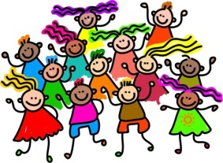  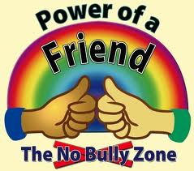  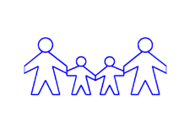  Relationships and marriage?  Families  No to Bullying  Making and keeping Good friendships  Making Good boundaries online and off | - Explain why showing gratitude for the love we receive from our friends, family, school and community can have a healthy impact  - Give examples of how respect can be shown to people who come from different kinds of families to our own  - Explain how different wedding ceremonies could help people understand the commitment of marriage (RE)  - List the places that people can go to for help and get support whenever relationships in families, with friends online or with strangers make them feel lonely, unhappy, pressured or uncomfortable.  - Explain why it is important to welcome those people who others might leave out and make efforts to understand and enjoy people who are different to you  - Explain how someone can be a good friend, categorise the key features of a good friendship, and talk about the ways in which they can cope when there are fallings out and how someone can make peace again and not resort to violence.  - Explain how someone can think carefully of the needs and preferences of the other person in their friendship or family and how they might make them happy and listen to their choices.  - Describe what it means to have high expectations in friendships and family: list some of the behaviours that should never be acceptable  - Explain how stereotyping and bullying can be damaging for someone.  - Describe what it means to be to be an upstander not a bystander when bullying occurs offline and online.  - Explain how to report bullying and support the person who has suffered unkindness.  - Explain what right and wrong touching is and show an understanding of what is appropriate behaviour in private and in public, explain what a bad secret is like and how to get help.  - Describe what resilient behaviour is like and stay hopeful even when it feels that families, friendships or other relationships are not working and are making you unhappy  - Explain how people can accept forgiveness and say sorry when they are selfish or unkind to their friends and family and explain how people can change their behaviour in the future.  - Describe the benefits of enjoying friends and family members and staying faithful and loyal to them overtime

Vocabulary | Definition
Relationships | A connection between people
Marriage | An official bond to mark a union between two people , it can be recognised by law, religion or society
Stereotypes | Categorising a group of people and simplifying or standardising then as being the same ie “All boys are …….. All teachers are …….
Church School Vocabulary | Definition
ETERNAL | Our CofE School believes that God has always loved us and will never stop loving us even if humans may let us down or hurt us
CREATED | That everyone is made in the image of God and therefore we should always treat one another as sacred and special and never as a thing or an object
FRAIL | That all people will make mistakes and are capable of disappointing us or worse
EXPANSIVE | God wants us to work towards wholeness and reconciliation with others who let us down and who we let down and calls us to live better, more holy and God supported lives.  God created a huge diversity of people and we need to be expansive to learn from and enjoy people even if they are not like us.
WORTHY | All humans are of ultimate worth and are precious and so we are all worth protecting and keeping safe from harm
INCLUDED | We learn that we are included and valued by our community and we will ensure that we don’t bully or stereotype anyone else and we will be upstanders when we see bullying of others.
FORGIVEN | Our school foundation believes that if we say sorry and stop our harmful behaviour we may be offered forgiveness. In most cases, it is right to try to forgive others when they harm or upset us.
FAITHFUL | We should try to maintain our friendships and relationships so we have support and sustaining joy through our lives. We should communicate to our friends and family through words and actions that we appreciate the love and care that they offer.

