What should we know? | Connections (using images) | What should we be able to do?
- That our school believes that you are loved and welcomed into the family of God  - That families are places where people grow and can be safe and are given love  - That people in my school have different kinds of families who look after them  - That my school is another kind of family where I am safe and am given love  - That if I do not feel happy or safe in my home family or school family there is someone to go to for help.  - Why friendships are good for us.  - How we can be a good friend.  - How we can show respect to other people who might be different to us  - What bullying is and some of the different ways people bully each other.  - How to get help if you feel you are being bullied  - What is right to keep private and what are bad secrets  - That our bodies belongs to us and there is safe and unsafe touching  - How to ask for help if you feel unsafe feel bad about any adult |   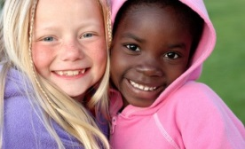  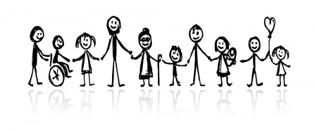  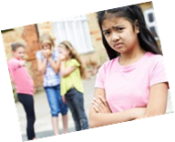  Keeping Safe online and off  Friendships  No to Bullying  Families? | - Talk about our families and the people who give us love (including the school as family and the Church’s idea of the Family of God)  - Talk about how we might show that we enjoy being in our families  - Show that we understand that different people have different kinds of families  - Know where to go for help if we feel unsafe or unhappy in our family or school  - Describe what a good friend is like  - Show kindness to someone who is a friend in a way they will like  - Describe why it is good to be able to show kindness to someone who is not our friend and try to include them in a game or activity  - Describe what bullying is, the different kinds of bullying and why it is hurtful  - Know where to go for help if you are bullied  - Talk about why it is good to be kind with our words and hands  - Talk about how our bodies belong to us  - Identify what is safe and unsafe touching  - Know that it is wrong to keep bad secrets and that people should not ask us to do that.  - Tell a trusted adult if we feel unsafe

What words should we understand and be able to use and underpin our relationships education as a CofE/ Methodist School.

Vocabulary | Definition
Family | A group of people living together , often it is made up by a parent or parents and their child or children
Friend | A person who you know well and like and who likes you
Bullying | Actions that are unkind, that frighten or hurt people and make them feel picked on or outside the group
Safety | Keeping away from danger or harm
Boundaries | Making limits to keep you safe
Church School Vocabulary | Definition
ETERNAL | God has always loved us and will never stop loving us
CREATED | We are specially made by God and so is everyone else
FRAIL | Sometimes all people make mistakes
EXPANSIVE | God loves all the different people and want us all to grow more into being good and kind to each other
WORTHY | Everyone is special and really worth keeping safe
INCLUDED | No one should be left out or made to feel they are not as lovely as other people
FORGIVEN | If people say sorry they should be allowed a fresh start
FAITHFUL | It is good for us to keep sticking with our friends and family

