What should we know? | Connections (using images) | What should we be able to do?
- How people choose to have babies and when is it the right time?  - How most babies are made  - What happens in sexual intercourse between a man and a woman  - The names of the body parts involved in sexual intercourse  - That sexual intercourse can be an incredibly delightful and a spiritual union between two people, and how this ultimate closeness can affect people physically and emotionally  - About Laws about the age of consent for sex  - That some people believe the best context for this level of closeness is in along term faithful relationship such as marriage  - Some people don’t choose this option and prefer to be celibate (not have sexual intercourse with anyone)  - What happens at conception  - What happens between conception and birth ( gestation Science)  - That having a baby can be a wonderful event in people’s life and is a huge responsibility | Sexual Intercourse  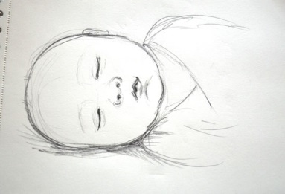  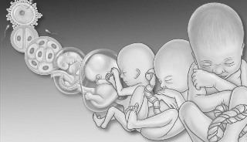  Conception    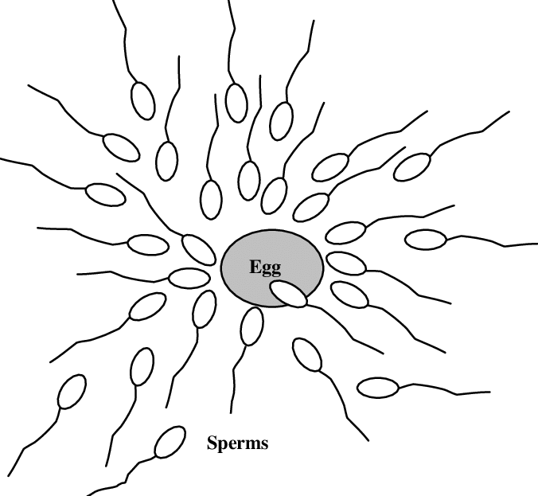  Babies  Gestation (pregnancy) | - Explain what happens in sexual intercourse between a man and a woman  - Name the key parts of the body involved in sexual intercourse  - Explain how close intimate relationships might affect people physically , emotionally and spiritually  - Describe why some people argue that the best time for such closeness is within a long term faithful committed relationship such as marriage  - Explain why it is important to only do this when you are at least 16 (Law - British Values/ Citizenship) and when you know it is right and both people will cherish each other (in some beliefs or cultures the only right time is within marriage)  - Explain what happens at conception and be able to explain the journey from pregnancy to birth (gestation Science)  - Explain that some people make a positive choice for themselves not to have intercourse with anyone  - Talk about why having a baby is wonderful but a huge responsibility
Vocabulary | Definition
Vagina | the passage in a woman that leads from a uterus to the outside opening of the female sex organs
Uterus | also called the womb - the place a baby grows
Penis | a male organ of sex which contains a channel through which sperm leave the body. It is also used to discharge urine from the body.
Sperm | a cell that can fertilise an egg made by a female, so that they can reproduce
Sexual intercourse | (hetero)sexual intercourse involves the penetration or insertion of the penis into the vagina .
Celibate | the state of voluntarily choosing not to have sex, to couple or get married
Conception | the action of a sperm entering an egg and a new life beginning
Gestation | the process of a baby growing, inside the womb from the time of conception until birth
Pregnancy | the state of having one or more babies growing in the womb
Parent | a mother or a father
Church School Vocabulary | Definition
Created | the school’s foundation believes that all people have been created by God, in the image of God, and so deserve to be observed and cherished.  as image bearers of God , we too are privileged to be given the power to create life and have the duty of using that power wisely and to take on the responsibility for the nurture of new life as parents.
Worthy | we are worthy of being protected and careful with ourselves and we are worthy of being delighted in.
Faithful | staying true to someone and sticking by them, being loyal and constant even when it is tricky, travelling through time with someone and not giving up (unless to do so would harm yourself or someone else).

