What should we know? | Connections (using images) | What should we be able to do?
- How to express our feelings and understand how others might be feeling  - That our responses to our feelings can effect others  - That exercising and being outdoors can make us feel better  - How to plan a healthy diet and the risks of a poor one  - The facts about smoking alcohol and drug-taking  - About basic first aid, how to make an emergency call and deal with some common injuries  - That good sleep , rest and some kind of spiritual practice can help us have good health  - That self care for protection and hygiene are important  - That helping others and volunteering or campaigning for a better world is good for us  - That making time to be still, pray or meditate can help us  - It is good for us to have friends and hobbies  - Who we can turn to for help if we are unhappy or worried  - How to create good rules that keep us safe online  - Understanding the ways that people use the internet for bad purposes and how to avoid harm  - That we are all special and my school believes everyone is loved and made by God  - What puberty is and how bodies change  - How to ask for help if I need it. | Exercise, Good rest, sleep and personal care  Basic First Aid    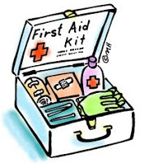    Screen time? Good rules?    Understanding Puberty    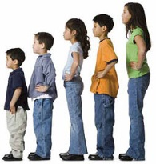  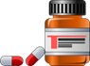  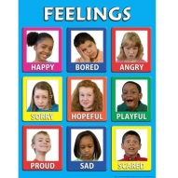    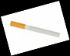  Talking about feelings  Facts about drugs alcohol and tobacco  Healthy food and self-care | - I can talk about how people can express their emotions such as anger and fear, and manage them so they do not have a negative impact on others  - I can outline how to spend time well with others and can talk about the importance of hobbies and interests  - I can describe how to be safe on the internet and explain how to avoid cyberbullies and cyberbullying  - I can list what makes wise choices online and explain why limiting screen time is a good idea  - I can explain why humans are worth looking after and why most Christians believe humans are made by God and so are precious and therefore they should look after the gift they have been given (Stewardship)  - I can describe different kinds of exercise and explain why it is good for your health, PE and Science  - I can explain why good sleep and rest are important and why considering some spiritual activity is good for your wellbeing.  - I can explain why helping others, volunteering or campaigning for a better world might help my health  - I can plan a healthy diet and express what the dangers of not being careful in choices about food.  - Explain the facts and laws surrounding, alcohol, smoking and drugs might be. Science  - I can explain how to make an emergency call, and demonstrate how to apply basic first aid for example dealing with common injuries including head injuries  - I can demonstrate how to look after my teeth and my skin in the sun. I can explain why this is important and what happens if people do not do this  - I can talk about how to practice personal hygiene and can explain why it can be anti-social not to do so.  - I can talk about puberty and how it effects girls and boys, particularly the emotional and physical changes including periods Science  - I can ask the appropriate people for help if I need it

Vocabulary | Definition
Healthy | Being of fit mind and body : being free from sickness
Cyberbullying | Bullying that is done by posting hurtful messages on the internet
First Aid | Emergency medical help given to a hurt or sick person while waiting for a medical professional
Hygiene | The practice of keeping clean to stay healthy and prevent disease
Puberty | The time in a person’s life when their body changes to allow them to be able to reproduce and have babies when they are ready and if they want to
Menstruation | The release of blood and mucus from a woman’s uterus, this usually happens in for 4 or 5 days, once a monthly from puberty until menopause (when a woman stops being able to reproduce).
Church School Vocabulary | Definition
Created | Our School believes that we have been created and are carefully and wonderfully made
Dignity | Our school believes that we need to see ourselves and treat others with huge respect as people who are crafted by God.
Worthy | Having great value .We are all worthy of being looked after and protected.
Community | We are a part of a group and in our relationships we need to realise we can have an impact on others. We need to try to show kindness and help everyone feel happy and safe. Jesus taught “Love your Neighbour as yourself” Matthew 22. 37 - 39
Frail (Fallen) | People are sometimes inclined to make poor choices for their own well being, this is part of being human.
Forgiveness | We can start again, if we recognise our bad choices and start afresh. Christians believe God can help you live with more care for yourself and others

