A Month with English Mystics

Background
We suggest that you do not do this month until you have completed the month on Centring Prayer.
We shall spend two weeks with the spirituality of the ‘Cloud of Unknowing’, and two with Mother Julian of Norwich. The anonymous author of ‘the Cloud’ sets the scene for this month.
In the opening chapters of his book, the author of ‘The Cloud of Unknowing’, describes four stages or phases of living the Christian life. Each of these phases involves the quality, or degree of both our experience and response to God’s presence in our life.
In the common way of life, our faith is seen as a source of moral guidance. It is a feeling of belonging to a community of people, or perhaps to our own faith tradition. It is a community devoted to service to the world.
The special way of life is where God becomes personally real to you, or to follow Christ in all things becomes personal to you. It is heartfelt. It is a life of devotional sincerity, lived with like-minded people, who have been similarly awakened through Bible study, prayer or service. This way of life brings holiness as we walk our personal journey through our lifetime with God towards God.
The singular way of life is “a blind stirring of love, a stirring of God’s Spirit within us, a stirring in the hidden centre of yourself and reverberating in your whole being. In a moment of unexplainable communion with God, it might be very intense. There is this taste, this sense of oneness”. These moments illuminate and energize your life. Your desire is to remain in these depths all the time, in that conscious communion with the stirring of God’s love within you.
The perfect way of life begins here on Earth, but it goes on forever. ‘In the simplicity and sincerity of your heart, there is a boundary crossing, it’s the gate of heaven you’re already passing through into the perfect way. Be perfect even as your heavenly father is perfect. Be infinite, even as God is infinite. Be boundary-less, even as God is boundary-less, this is our destiny. So that, even though we’re still here, the celestial eternal destiny is already mysteriously unfolding in our heart, in the quiet mystery and simplicity of this prayer’.

Week 1
The Cloud of Unknowing is a 14th century spiritual classic written by an anonymous English monk, who wrote in every-day language because his purpose was to give practical guidance to people for their direct experience of God. Education or high social status did not matter, only a sincere longing to encounter God. He writes for those “presently engaged in the active life who are being prepared by grace…those who feel the mysterious action of the Spirit in their inmost being stirring them to love... [who] now and again taste something of contemplative love in the very core of their being.” Is that a description of you now, or of you as you would want to be?
His instruction is for a very practical sort of mysticism for anyone; withdrawal from the world (as in a monastery) is not essential, letting go of attachments to people, expectations, and things is. He advises on contemplative practice and on developing a true spiritual discipline. This requires intent, willingness, openness and practice.
Set aside 20 min each day this week to be silent in God’s presence. Anywhere quiet where you will not be disturbed will do. Simply sit in mental quietness and pause to appreciate being in God’s presence. After two such days, read on!
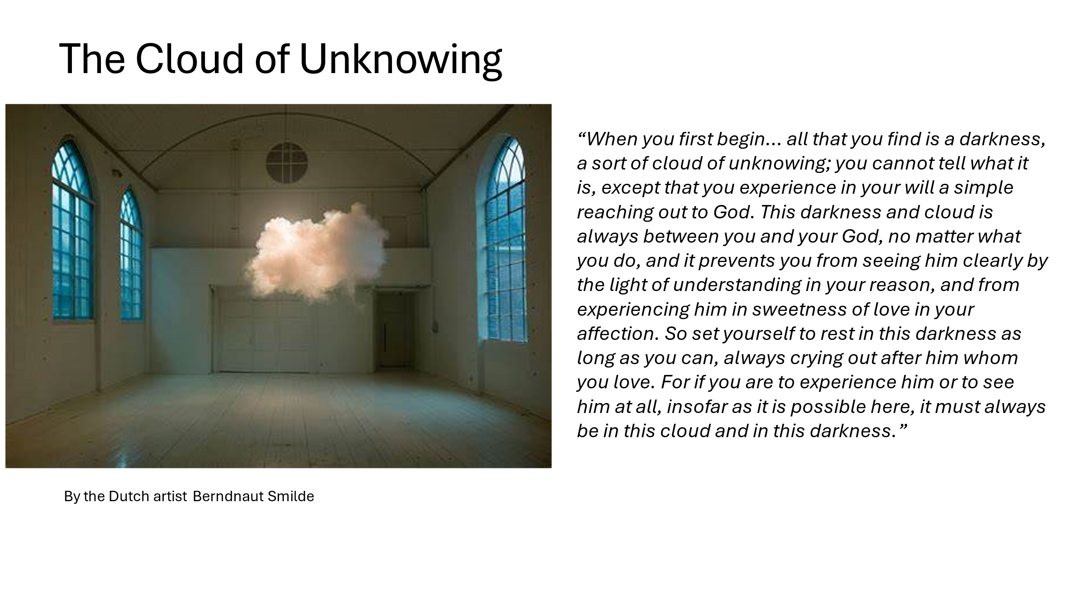
The author of ‘the Cloud’ says that much of our contemplative practice will feel like failure, but he encourages us to continue “let the wonderful transcendence and goodness of God teach you humility rather than the thought of your own sinfulness, for then your humility will be perfect. Attend more to the wholly otherness of God rather than to your own misery.” Persist in silence for another two sessions, do you now feel yourself to be ‘simply reaching out to God’?
The ultimate goal of the work described in The Cloud of Unknowing is union with God, not as God is thought of or imagined to be, but as God truly is in [God’s] nature. This is an experience in which we seem to be transcending our own Self, but in fact, we are discovering our Self as we truly are…We come into contact with our own ‘naked being’ and, by means of this, come into contact with God as God truly is. We are existentially united in Divine Reality. Does this encourage you to spend another week with ‘The Cloud’, if not, skip to week 3.
Week 2
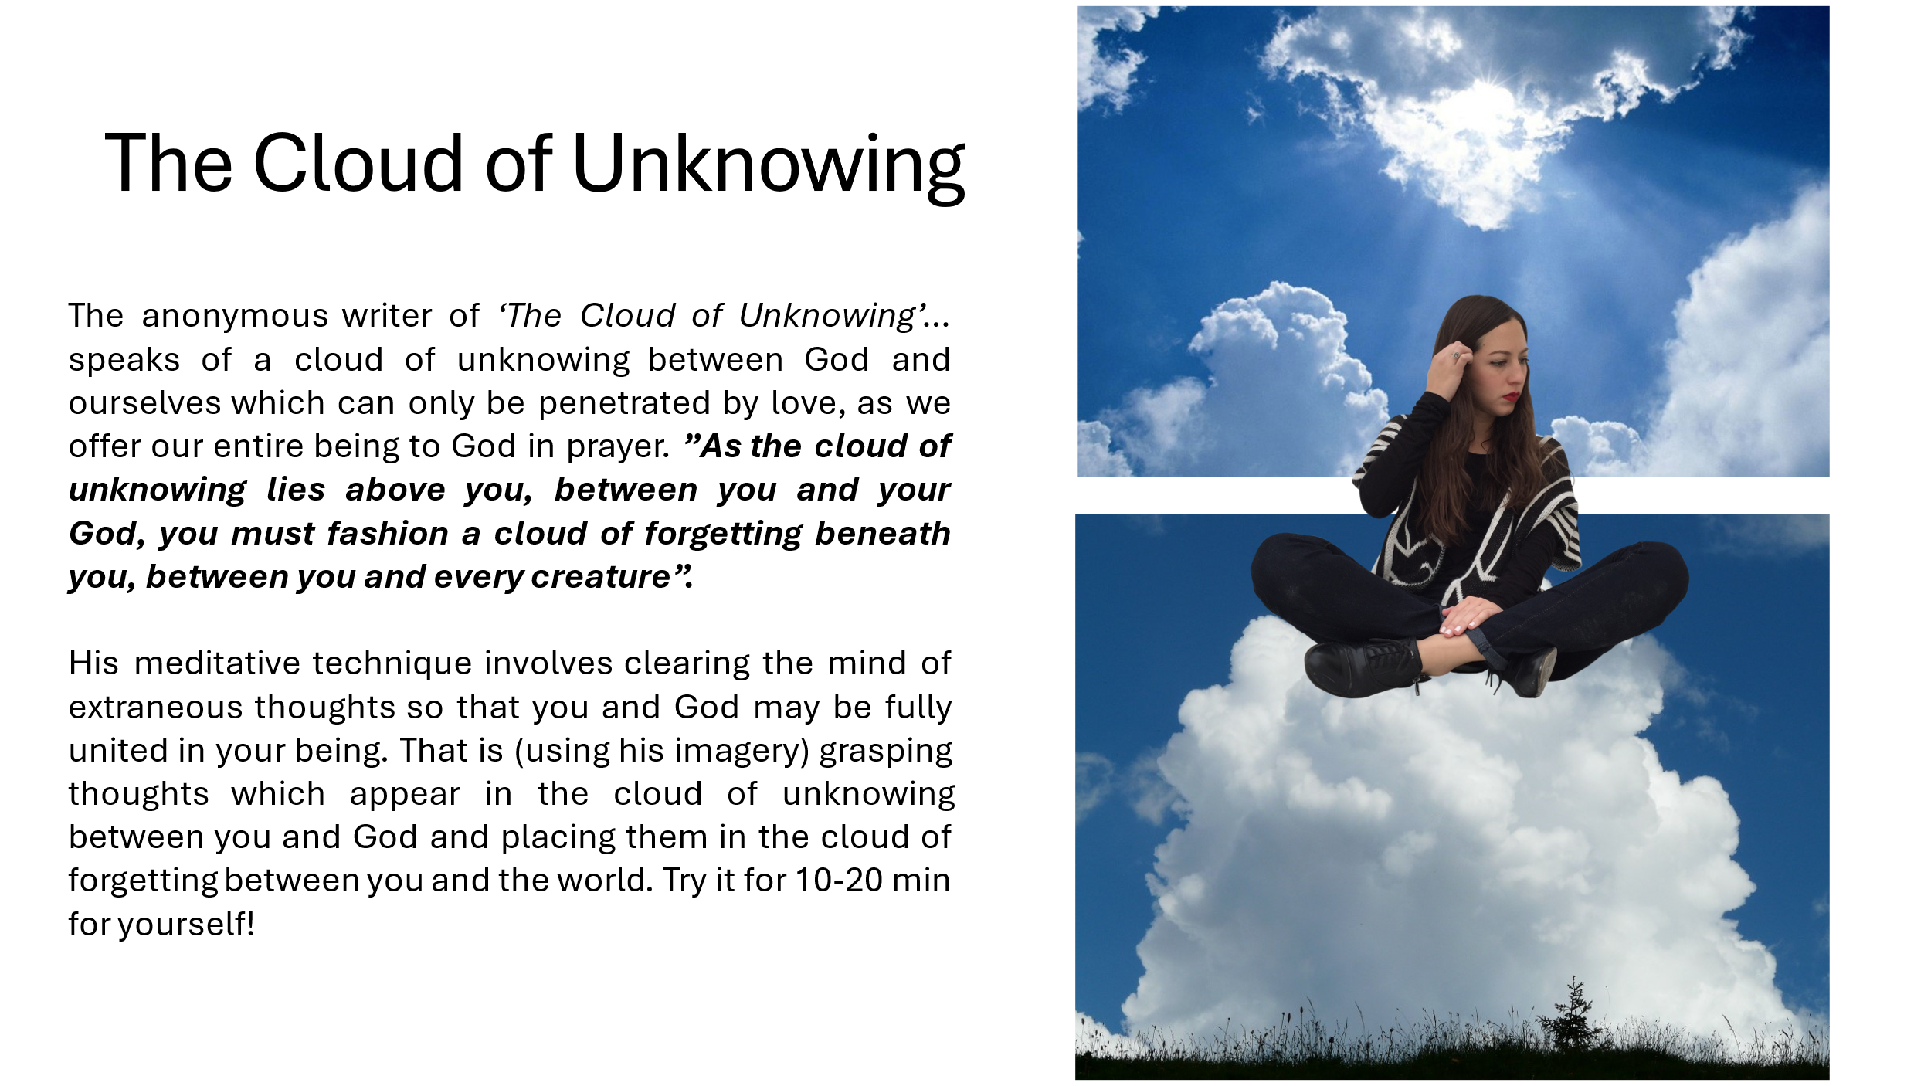
The author of ‘the Cloud’ writes: “Thought cannot comprehend God. And so, I prefer to abandon all I can know, choosing rather to love him whom I cannot know. Though we cannot fully know him we can love him”... In the later stages of the journey, of course, loving becomes its own kind of knowing—the deepest kind of knowing.” Seeking after God as we have been, requires whole being participation; it is not a simple mental exercise. We need to clear our thoughts. The author suggests a ‘Cloud of Forgetting’ technique. Try this for three sessions.
Persistence is key to following the way of ‘The Cloud’. Gradually frustration and failure give way to love and communion. “Lift your heart up to the Lord with a gentle stirring of love, desiring him for his own sake and not for his gifts, centre all your attention and desire on him, and let this be the sole concern of your mind and heart. Do all in your power to forget everything else, keeping your thoughts and desires free from involvement with any of God’s creatures, or their affairs, whether in general, or in particular. Perhaps this will seem like an irresponsible attitude, but I tell you, let them all be, pay no attention to them.” Continue for two further sessions.
‘In deep meditative consciousness, that is in states of sustained attentiveness, infused with love, we begin in very subtle, but real ways to sense our inner penetration of time and eternity’. In a third session meditate on this. Then evaluate your progress so far. Will you want to repeat this fortnight at a later date?

Week 3
The anonymous woman, whom we name Julian after the church in which she eventually led her life as a Christian mystic, was born (b1342) into turbulent times in Norwich. The hundred years war caused widespread poverty, but Norwich fared better than many cities. The Black Death arrived in 1349. The Peasants Revolt was violently quelled by the Bishop of Norwich in 1381. The Great Western Schism (1378-1417) created a tussle for authority between three Popes. Amid this chaos and deprivation, Julian became seriously ill, a near death experience.
In a single day, 8th May 1373, Julian was given 15 ‘showings’ by God. She spent the next 20 years as an anchorite in the church of St Julian in Norwich, processing these experiences until their meaning became clear to her. In 1388, she realised that “Love was his meaning” and only then revealed her showings in her great work ‘Revelations of Divine Love’ – the first book by a female author in the English language. She died around 1417.
In a session, ponder the events of Julian’s life. How would you have reacted to them if you had lived in her days?
In another session, ponder the themes of Julian’s writings (below). Which seem most confusing? Which seem most relevant to you in today’s world?
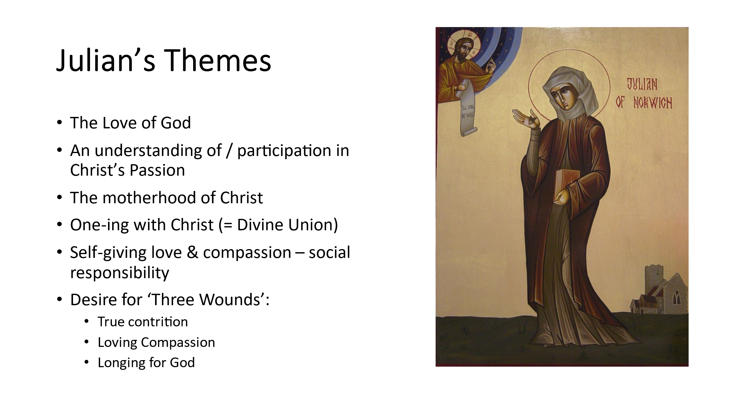
Here are three quotes from Mother Julian on prayer: “Rest in the goodness of God, knowing that that goodness can reach right down to the lowest depths of our need”. “Fill our prayers with thanksgiving as this implies confident trust”. “Prayer unites the soul with God.”. Rest; Thanksgiving; Union; do any of these characterise your life of prayer? So often, we protestants feel guilty at resting in prayer, we feel the need to pile up many words; we ask for, more than we give thanks for; we are suspicious of the language of union, preferring that of sinfulness. We feel we need permission to pray as Julian prayed: you have all the permission you need. Practice Rest, Thanksgiving, and allow Union for at least three sessions.
Perhaps the most famous meditation of Mother Julian was that on of a hazelnut:
“He showed me a little thing, the size of a hazelnut, in the palm of my hand, and it was round as a ball. I looked at it with my mind’s eye and I thought, ‘What can this be?’ And answer came, ‘It is all that is made’. I marvelled that it could last, for I thought that it might have crumbled to nothing, it was so small. And the answer came into my mind, ‘It lasts and ever shall because God loves it’. And all things have their being through the love of God”.
“In this little thing, I saw three truths. The first is that God made it. The second is that God loves it. The third is that God looks after it…What is He indeed that is maker and lover and keeper? I cannot find words to tell. For until I am one with Him I can never have true rest or peace. I can never know it until I am held so close to Him that there is nothing in between.”
There is material in this for a number of meditation sessions. Try using: “It lasts and ever shall because God loves it”. Try also: “All things have their being through the love of God”.
In a separate session, meditate firstly on the hazelnut universe: “God made it”, then “God loves it”, then “God look after it”.
In separate sessions use: “What is He indeed that is maker, lover and keeper?” and “I am held so close to Him, that there is nothing between us”.

Week 4
Divine union is a major theme in Julian’s writing: she called it One-ing, becoming one with God. For her, this was no New Testament metaphor, but a lived reality.
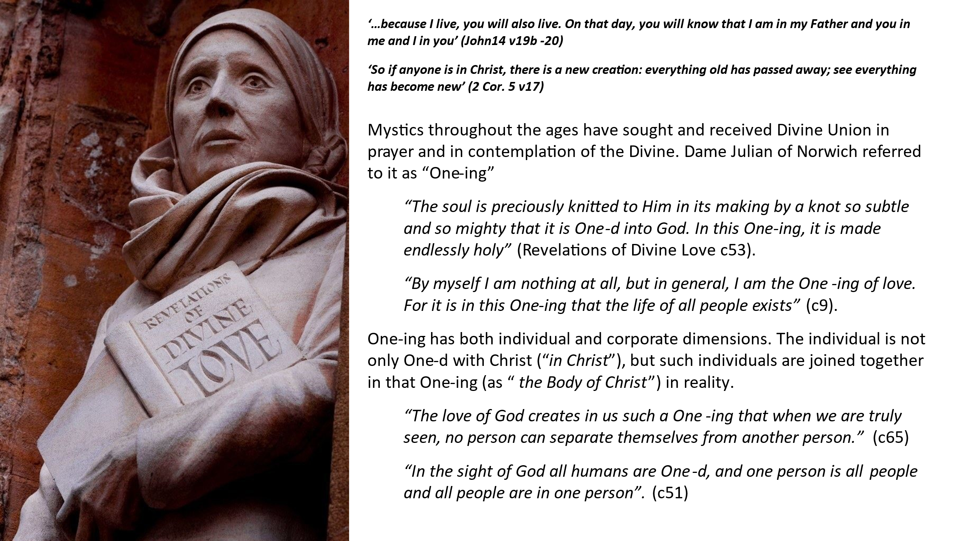
In a session, ponder Julian’s writing on the individual ‘One-d’ with God (above). Have you experienced this One-ing in your prayer life? How might you experience this more?
In another session, ponder Julian’s writing on the corporate dimension of One-ing (above); we are One-d with each other as well as with God. Have you ever experienced such One-ing with other people? Julian says that God sees us all as One-d together with Him (c51 above). How are you reacting to this?
It is on this basis of One-ing that Julian was able to write another of her most famous sayings:
“All shall be well, and all manner of things shall be well… for there is a force of love moving through the Universe that holds us fast and will never let us go”.
This is no casual or altruistic optimism; it arises from a deep conviction of the nature of God and our union with the Divine. Meditate on this for a session.
Finally, review your month with the English Mystics. Have you grown in faith or love or One-ing this month? How will you take this forward, if at all?

Follow-up Resources
- Turning to the Mystics — CAC Podcast with James Finley (podcasts on ‘The Cloud’)
- Spearing AC (2001) The Cloud of Unknowing and other works Penguin
- Holt B (1999) The Wisdom of the Cloud of Unknowing Lion
- Windeatt B (2015) Julian of Norwich, Revelations of Divine Love Oxford UP
- Starr M (2013,2022) Julian of Norwich, The Showings: Uncovering the face of the feminine in Revelations of Divine Love Hampton Roads PC
- Gilbert C (2024) I Julian: The Fictional Autobiography of Julian of Norwich Hodder & Stoughton
- Text of Julian’s writings is available here: https://www.documentacatholicaomnia.eu/03d/1343-1398,_Julian._of_Norwich,_Revelations_Of_Divine_Love,_EN.pdf
- https://www.youtube.com/watch?v=DBffy_Pqyq0
- https://www.youtube.com/watch?v=u6IPC4Ff-iQ

iab/2/10/24 VF

