What is spirituality?
‘All human beings are spiritual people.’ The following books acknowledge children’s innate spirituality and that childhood is a natural source of spirituality. Many of these books are examples of an expression of that spirituality and therefore may enable the reader to express their own spirituality. Some of these texts nurture and express a longing for God and explore worship. Some are distinctly Christian; others distinct to other worldviews and faiths.
It is not easy to pinpoint exactly what spirituality means and looks like, but this only adds to the richness of children’s spiritual capacity. The following texts add to and enhance something that is innate within children, rather than something that can be added on or discretely taught and learned. This approach enables us to value each child as an individual and plan and facilitate something that adds to their flourishing as spiritual beings.
Observing her newborn, Nye begins to define human spirituality as:
- delighting in all things
- being absorbed in the present moment
- not too attached to one’s self
- eager to explore boundaries of ‘beyond’ and ‘other’
- searching for meaning
- discovering purpose
- open to more
Spirituality can be quite felt and sensed and known in a different way to other knowledge and learning. Consider something that inspires and generates awe – often that is outside of one’s self but deeply affects our ways of being.
Spirituality can be described as, ‘signals of transcendence that are normal aspects of life but all at odds with a materialistic understanding of the world, they point to something other – something more… and can lead people to religion.’ Spirituality is other than the material: it can be hidden, but can be obvious. You do not have to be adult, or ‘mature’ to be spiritual.
Many people would say they are ‘spiritual but not religious’. Many would say that their spirituality is a very personal thing and this too can over-complicate it and make it hard to define. Having said that, spirituality does not need to conform to a definition. Many Christians would define spirituality as simply ‘ways of being with God’ or ‘God’s ways of being with us’ Christians believe God creates and initiates spiritual encounter. Children experience spirituality as the sacredness of life, even its preciousness, its vulnerability.
‘He took a little child whom he placed among them. Taking the child in his arms, he said to them, “Whoever welcomes one of these little children in my name welcomes me; and whoever welcomes me does not welcome me but the one who sent me.”’
How can children’s spirituality flourish?
It may be possible to limit or even damage children’s innate spiritual capacity so we as adults must take care to nurture and provide space and opportunity for spiritual development. Children have a natural capacity to appreciate mystery and the ‘ungrasp-ability’ of life. They do not judge so easily; they are used to discovering and enjoying new things. Thery are naturally curious and they know that they do not always need – or even possess – the language necessary to understand and interpret everything. As adults, we have lost many of these vital aspects of living which can limit our own capacity for spiritual experience. How comfortable are we with new experiences? How open are we to fresh perceptions of the world around us? How often do we seek and pursue that which is not material? How often do we take time to wonder?
The following books have been added to this list because within their pages they describe spiritual experiences, often completely from a child’s perspective. Sometimes it is as a journey, an encounter, a realisation, a perspective. Sometimes God is named and mentioned, sometimes not. These books (some to a greater degree than others) enable children to take time to
- identify new feelings and emotions within themselves
- discover identity and purpose
- experience a different culture or faith perspective
- consider a world beyond their own
- develop empathy, gratitude, duty
- consider that which is outside of themselves
- wonder and ask questions
- delight in and respond to the detail, the tiny, the minute, the precious
- delight in and respond to the vastness of the universe and the world around them
- play, sing, dance, experience art
self
others
beyond
beauty

Please note: these books are not suggested so as to enable spirituality can be measured or assessed – simply to provide space and opportunity for children’s spirituality to flourish. Children may respond verbally – they may not. Consider whether response is necessary, and what it might look like for different children. Notice what the children may be feeling, regardless of whether they are able to articulate them.
Needless to say, this is not an exhaustive list and will hopefully inspire you to add to your own bank of books that allow space for children’s spirituality to be acknowledged and to flourish. Books have been categorized under some basic headings, but many fall in to more than one:

- Heaven & Life after Death
- Mystery
- Prayer
- Religion & Faith
- Worship
- Creation
- God
- Relationships
- Grief & Loss

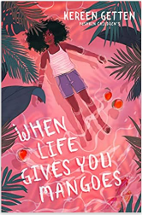
When Life gives you Mangoes
Keren Getting
Grief & Loss; Prayer; Religion & Faith; Mystery

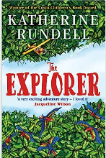
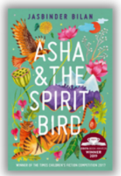
The Explorer
Katherine Rundell
Grief & Loss; Prayer; Mystery

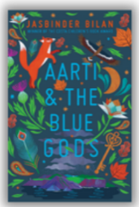
Aarti & The Blue Gods; Aisha & The Spirit Bird
Jasbinder Bilan
Grief & Loss; Prayer; Religion & Faith; Heaven & Life After Death
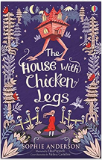
The House with Chicken Legs
Sophie Anderson
Grief & Loss; Prayer; Religion & Faith; Heaven & Life After Death

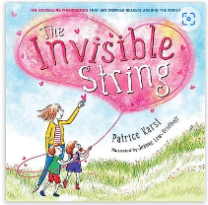
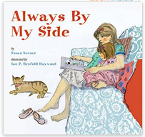
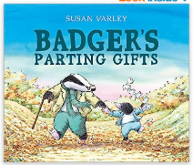
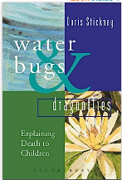
Grief & Loss; Religion & Faith; Heaven & Life After Death

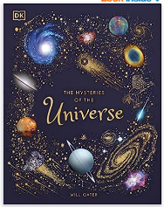
Creation; Mystery; God

Books that explore our place in the world.
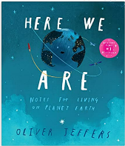
Here We Are
Oliver Jeffers (plus others by this author)
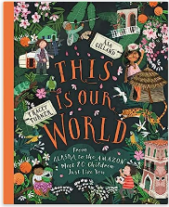

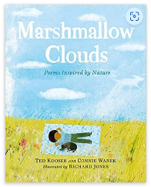
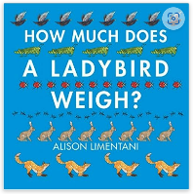
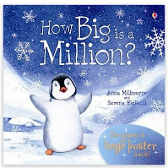
Creation; Mystery; God; Relationships

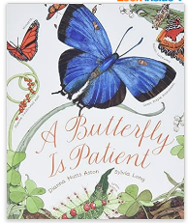
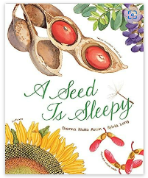
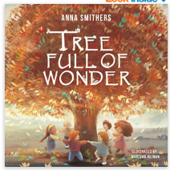
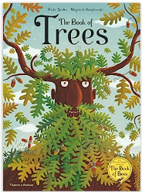
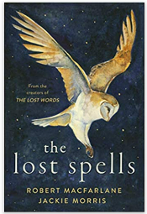
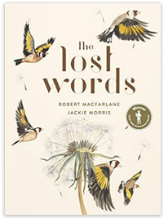

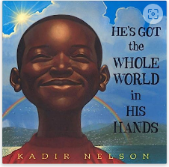
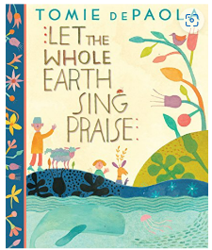
Creation; Worship; God; Prayer; Religion & Faith; Relationships
Creation from a Christian perspective

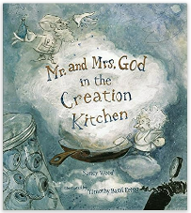

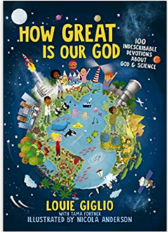
A Christian perspective on God and science
Louie Giglio
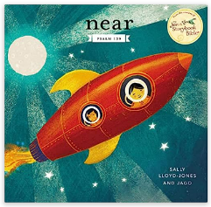
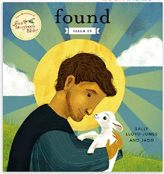
‘found’ and ‘near’ + others
Sally Lloyd-Jones
Key Bible texts explored through themes

Religion & Faith; Worship; Relationships
Books that explore identity through faith and culture.
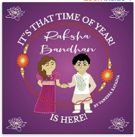
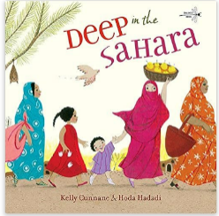
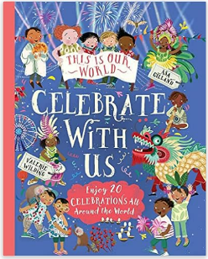
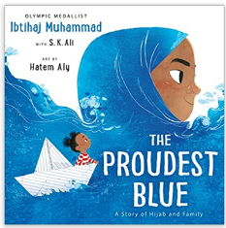
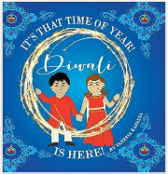
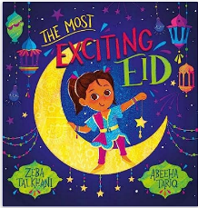
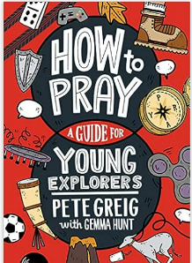
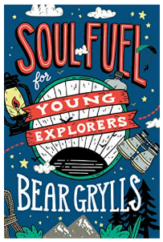
God; Religion & Faith; Prayer; Relationships;
Bear Grylls gives examples from his own life that have helped him to be string and courageous, even in tough times.

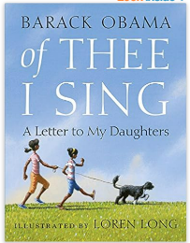
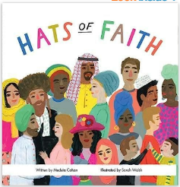
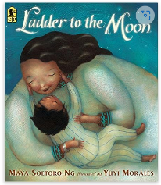
Relationships; Mystery; God
Books that speak of our interconnectedness and dependence on one another, and on the world around us.

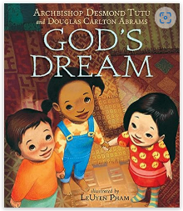
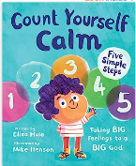
Books that suggest looking outside of ourselves for help with emotional regulation, mental health and wellbeing.

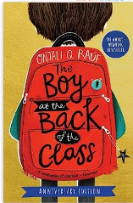
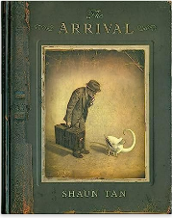
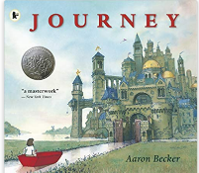
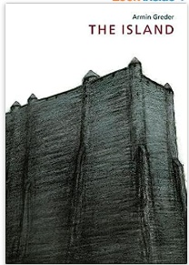
Relationships; Grief & Loss; Mystery
The Arrival
Shaun Tan

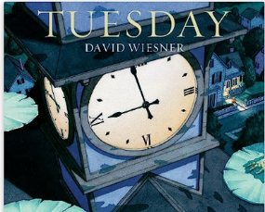
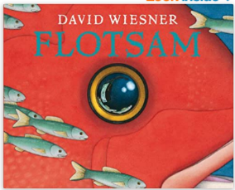

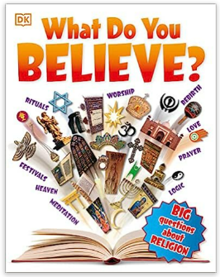

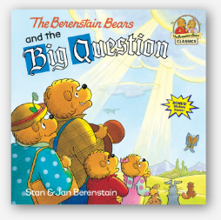
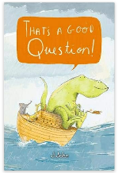

Books that facilitate wonder, awe and allow children to ask questions that don’t necessarily need answers!

Children’s Spirituality R Nye 2009
Brenda Watson
Children’s Spirituality R Nye 2009
Mark 9:36-37

