B5. Guidance for a Governors’ meeting (including C4 + C5)
For any governing body of a Church of England school, Relationships, Sex and Health Education (RSHE) is likely to be a subject that provokes discussion Educators and Policy makers are concerned that children and young people receive the most helpful education and guidance possible in areas that can really impact on wellbeing and life happiness. In many governing bodies there is likely to be a span of beliefs and opinions about the teaching of these subjects, and a governing body meeting to discuss RSHE can be one that might be regarded as needing thought-out planning.
It may be felt that an RSHE sub-committee could be temporarily established to discuss these issues and bring them back to the full governing body meeting
This is a suggested agenda:
The aim of the meeting:
- To discuss and agree the place that RSHE plays in the life of the school (C5 on this website)
- To decide whether this school (if a Primary School) wishes to include the teaching of sex education at KS2 (C4 on this website)
- To agree the first draft of the RSHE policy (which can become part of the parent’s consultation meetings/process).
[Suggested process: produce first draft of the RSHE policy, consult parents/guardians, use this consultation to support the production of a second draft of the RSHE policy, present the policy to the full governing body, make any necessary changes/amendments, ratify the policy at a meeting of the full governing body, then publish the policy on the school/academy website.]

- To review materials to be used in teaching.
Starter activity
A. Defining the world we live in and the world our children are being educated to inhabit.
Ask governors to read this extract taken from God, Gender, Sex and Marriage (Mandy Ford,
Dean of Bristol Cathedral, Jessica Kingsley Publishers, 2019):
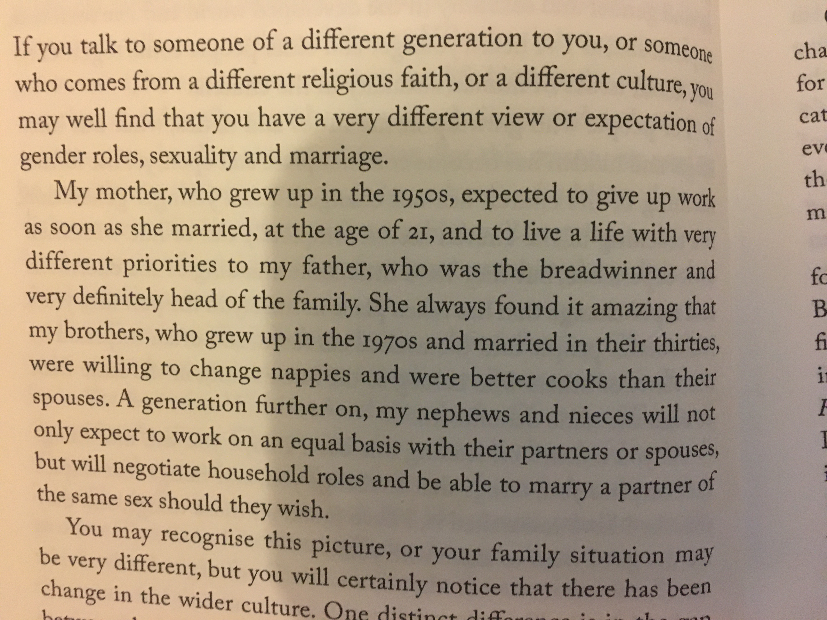

Questions
1. Does this accurately describe the changes that have taken place in the wider culture?
What have been your own experiences of cultural change?
2. In the light of these changes and the need to equip pupils to live in modern Britain, what does that mean for our Relationships, Sex and Health Education in our Church of England school/academy?

B)
Using C5 on this website, evaluate how RSHE will sit within the life of the school, and consider the connections that will need to be made with other curriculum areas and the life of the school.

C)
Using C4 on this website [primary schools and academies only], use the decision-making grid to help you make a conscious decision for your school community as to whether you will or will not include Sex Education in your curriculum for KS2 pupils.

D)
Look through the exemplar policy on this website (B2), which meets the requirements the Church of England Education Office and the Department for Education. You can adapt this exemplar policy or use it as the basis of a similar document in order that your RSHE policy appropriately reflects your school/academy’s vision, values and context.

E)
Ask governors to review the materials used in the school to deliver the RSHE curriculum. By utilising the support materials available at www.goodnessandmercy.co.uk, ask governors to evaluate how the school/academy can ensure that RSHE will be taught in a way that is underpinned by its Christian foundation and vision.

