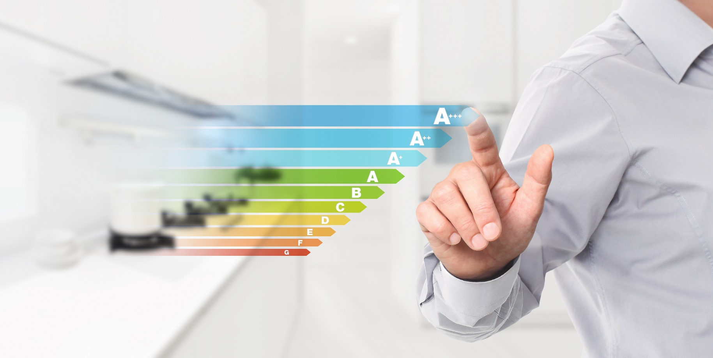

Net Zero 2030
Surgeries

Parish Buying, in partnership with 2buy2.com ltd, is proposing to launch a number of energy efficient solutions to support the Church of England’s 2030 Net Zero carbon target. These will be made available via the Parish Buying website: www.parishbuying.org.uk
Parish Buying is a buying service set up by the Church, for the Church. The contracts and discounts are available to all parishes, cathedrals and dioceses in the Church of England and the Church in Wales.
Through the bulk buying power of the Church, Parish Buying negotiates competitive prices with suppliers across a range of different contracts. All of Parish Buying’s suppliers undergo a careful selection process, and the contracts have been professionally reviewed, so you can purchase safe in the knowledge that there will be no catches or hidden surprises. Parish Buying manages the contracts too, and can guarantee ongoing support from our dedicated customer service team.
To achieve the target of Net Zero Carbon by 2030, it has been identified that low carbon solutions will need to be adopted across churches. To work towards this target, 2buy2 and Parish Buying are looking for churches interested in a Solar PV installation, who could potentially pilot this approach for the Church of England.
The Solar PV suppliers will be pre-vetted and under contract to deliver a service that is both successful and sympathetic to your site. The procurement team at 2buy2 will be with you every step of the way and will manage the contract on your behalf, ensuring that delivery of the installation is achieved to its full potential.
2buy2 in partnership with Parish Buying, will be running a surgery to explain the proposal and discuss further the solutions planned to be launched during the first quarter of this year, which will be:
- Solar PV
- Under Pew and Infrared heating solutions
- Data loggers and energy saving devices.

The surgery will allow you to listen to the proposed solutions and ask any questions you may have at the end.

The dates for the surgeries will be:
- Tuesday 2nd February 2021 10am – 11am
- Thursday 4th February 2021 2pm-3pm
We will also use the opportunity to discuss the full range of proposed solutions which will be 16 in total. 8 of them will run as pilots, and 8 will run as ‘off the shelf’ packages.
Please email Jonathan.williams@2buy2.com if you would like any more information in advance of any of the solutions proposed.

