The Mothers’ Union Prayer
Loving Lord,
We thank you for your love so freely given to us all.
We pray for families around the world.
Bless the work of the Mothers’ Union as we seek to share your
love through the encouragement, strengthening and support of marriage and family life.
Empowered by your spirit, may we be united in prayer and worship,
and in love and service reach out as your hands across the world;
In Jesus’ name. Amen.

The Lord’s Prayer
Our Father in heaven, hallowed be your name. Your kingdom come,
your will be done, on earth as in heaven. Give us today our daily bread. Forgive us our sins, as we forgive those who sin against us.
Lead us not into temptation, but deliver us from evil. For the kingdom, the power and the glory are yours, now and for ever. Amen.

Hymn: Come and go with me to my Father’s house – Canadian Traditional or Lord, for the years – Timothy Dudley-Smith

Blessing
Remember all God has done. Rejoice in all he shall yet do. Put your hand in his, the God of past, present and future, and walk with him wherever he may lead, knowing he will walk with you, this day and always, Amen

Dismissal
May the God of compassion make you ready to give;
May the God of love make you ready to receive;
May the God of adoration make you ready to find where love dwells.
Amen

We say the Grace together



Bristol Diocese 2020
Material from Common Worship
Copyright © Archbishops' Council 2000

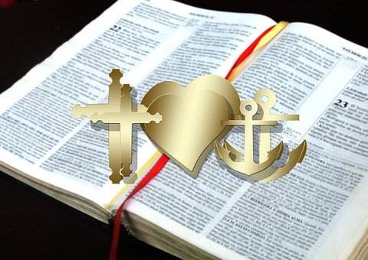

Mothers’ Union Wave of Prayer 2020

Building Hope & Confidence
Welcome to our Mothers’ Union Wave of Prayer Service.
‘Building hope and confidence’ is at the heart of our call to support individuals and families to transform their lives. So, we gather to celebrate our hope and confidence in God, which inspires and equips us to build hope and confidence in others, as we reach out in love and service.

Call to worship
Those who hope in the Lord will renew their strength. They will soar on wings like eagles; they will run and not grow weary; they will walk and not be faint.
Isiah 40:31-32

Prayer of preparation
Gracious God, giver of hope which sustains our lives we thank you.

Loving Father, we hope in your word: we trust in your plans for a future where we will thrive in showing love to those we seek to serve.

Saviour Christ, we hope in your word: we trust in your plans for a future where we will bear eternal fruit as we follow your commands.

Holy Spirit, we hope in your word: we trust in your plans for a future where we will be filled with power and guided in every truth.

Thanks be to God, for our sure and steadfast hope. Amen
Opening Hymn: In Christ alone my hope is found – Townsend/Getty, 2001

Confession
Merciful and loving God: When we are ungrateful, remind us of you grace,
When we are oblivious, open our eyes. When we are harsh, gentle our spirit.
When we are apathetic, show us the empty tomb. So, shape us and turn us around, that we will live with blessing and grace and light. Amen
B.M. Neal

Prayer of Forgiveness
May the God of love and power, forgive us and free us from our sins, heal and strengthen us by his Spirit, and raise us to new life in Christ our Lord. Amen

Let us declare our faith in God
We believe in God the Father,
Creator of all that is, whose mystery is beyond our understanding,
Whose love is always around us.
We believe in God the Son, Jesus, the incarnate Word,
Who suffered and died for us, our risen and living Lord.
We believe in God the Holy Spirit, Spirit of truth and love.
God’s power in the Church and the world,
Within our hearts to strengthen and sanctify.
Glory be to the Father, the Son and the Holy Spirit,
Now and forever. Amen

Hymn: Hope of our calling - © Rev Ally Barrett, 2006 (Tune: Woodlands)

New Testament Reading: Hebrews 3:1-6

Symbolic Action
give out cards/paper with anchor & rainbow & text (for everyone to take home)

Prayer
We offer up these symbols
of our sure and steadfast hope in God.
We affirm our confidence in his promises
and commit our witness and work to him. Amen

Hymn: Lord Jesus Christ (Living Lord) - Patrick Appleford, 1960

Intercessions
Living God, we thank you that we can put our hands in yours, and walk where you will lead us, confident that, though all else may fail, you will not, though heaven and earth pass away, your words will endure forever.

So we come in faith, with joyful hearts and in glad thanksgiving, to offer our worship, and to dedicate our lives once more to your service.

You have given us hope, and hope does not disappoint us.
Receive our praise, in the name of Christ. Amen
Nick Fawcett

Keep us, good Lord,
under the shadow of your mercy
in this time of uncertainty and distress.
Sustain and support the anxious and fearful,
and lift up all who are brought low;
that we may rejoice in your comfort
knowing that nothing can separate us from your love
in Christ Jesus our Lord. Amen

We give thanks for our projects, Friends for Parents, A.F.I.A, Cathedral Welcomers, Virtual Babies, knitted jumpers for children around the world & refreshments for visitors at Ashfield Prison. We pray for all whom we seek to serve that lives may be bettered and relationships thrive.

Today we pray especially for our Link Dioceses of
Pacong in South Sudan, Southern Nyanza in Kenya, Kutigi and Ijesha North
in Nigeria, and Karnataka Central in India.

Mary Sumner’s Personal Prayer
All this day, O Lord,
let me touch as many lives as possible for thee;
and every life I touch, do thou by thy spirit quicken,
whether through the word I speak,
the prayer I breathe,
or the life I live. Amen.

