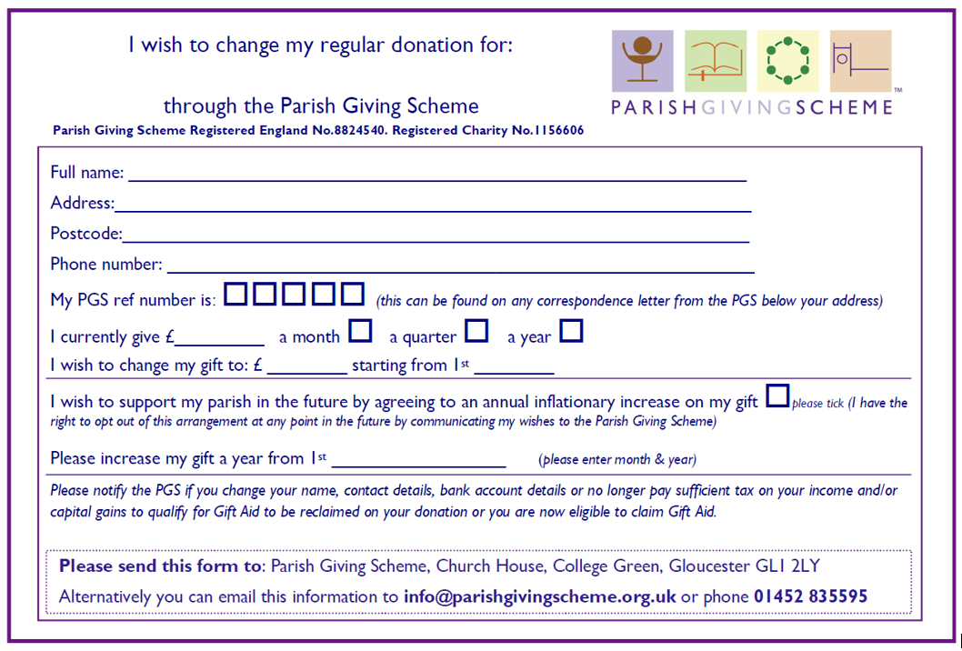

*Add name of Parish & Unique Parish Code*



*Add name of Parish & Unique Parish Code*