
Bereavement support for children and young people
Helpful Organisations
[Target audience: parents, carers and school staff]

There are many national and local support charities and organisations that offer a range of support for individuals, parents and organisations. Below are some of the charities and organisations with a well-established history of supporting those experiencing grief through a bereavement.

Bath and Wells Diocesan Education Team can support schools by giving advice and through the delivery of staff training or general advice and support. Please contact David Williams (Diocesan School Adviser): david.williams@bathwells.anglican.org or call 01749 670777 / 07736 903867. The DBE website also includes helpful information and resources for teachers who are supporting children through bereavement and loss. These can be found at:

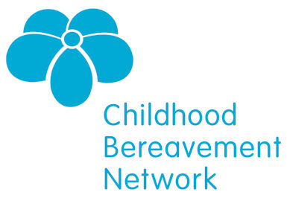
Child Bereavement Network
CBN supports professionals working with bereaved children and young people. The website includes lots of helpful information including resources which can be used to support children.
Tel: 020 7843 6309. Website: www.childhoodbereavementnetwork.org.uk

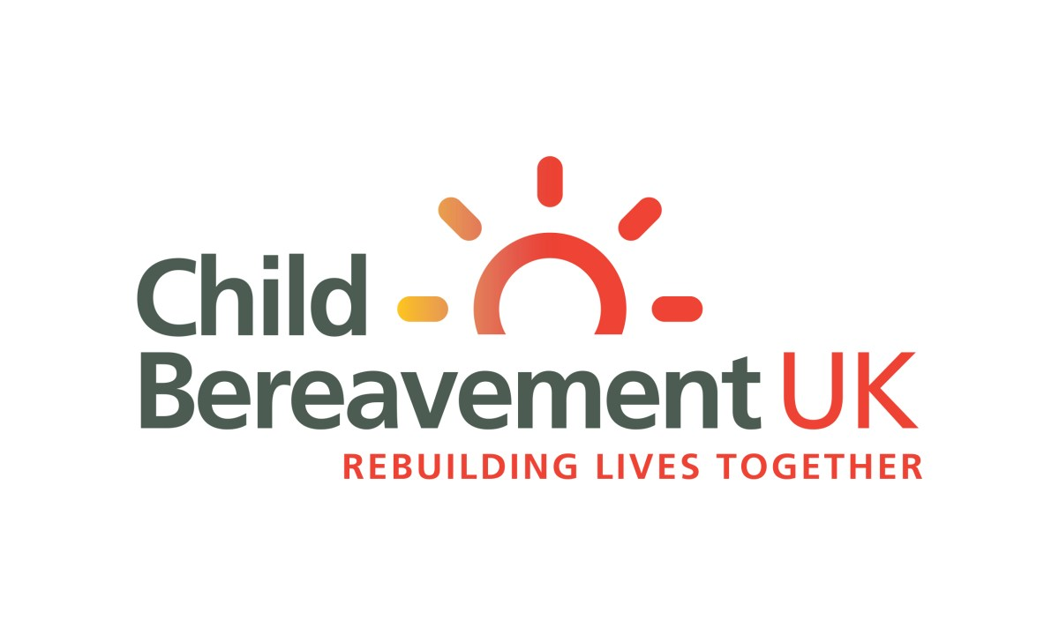
Child Bereavement UK Charity
Produces lots of ideas and support materials for children and their families.
Calls from schools are answered by someone with classroom experience.
Helpline line 0800 02 888 40. Website www.childbereavement.org.uk [Look under ‘Information and Support’ tab for different themes]

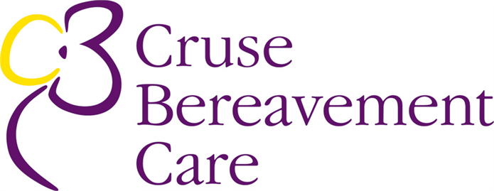
CRUSE Bereavement Care
Bereavement counselling service for adults and children but also produces resources and helpful leaflets. CRUSE offers a 1:1 counselling service from nearly 200 local branches.
Helpline: 0808 808 1677.Website: www.crusebereavementcare.org.uk
Aimed at children and young people: www.hopeagain.org.uk this is a website run by CRUSE for children and young people who have been bereaved and want news and information designed for them.

PAPYRUS
PAPYRUS has developed a guide to suicide prevention, intervention and postvention in schools and colleges. It aims to equip teachers with the skills and knowledge necessary to support schoolchildren who may be having suicidal thoughts with Save The Class resources. It runs HOPELINEUK where advisers can talk with children or young people under 35 or others who are worried about them. The Bedtime Stories resources highlight the impact of online bullying.
www.papyrus-uk.org

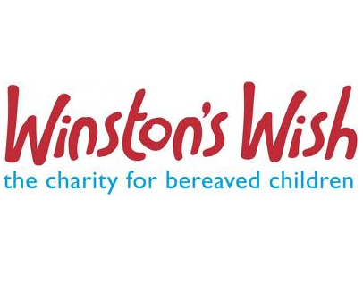
Winston’s Wish99
On line resources and advice especially for children and families
Tel: 01242 515157. Website: www.winstonwish.org.uk

Other support organisations

The Church of England’s Going for Growth has a web page filled of resources to support bereavement here. These include links to other sites such as ‘the power of language’ here and
Local Authority
Usually have the availability of professionals who can provide reactive support for schools in the event of sudden tragedies.
Contact LA in which the school operates
Care for the Family
A Christian based charity that seeks to support families in a range of areas including bereavement
www.careforthefamily.org.uk
Mothers’ Union
Useful support materials available especially when supporting bereaved children
mu@mothersunion.org

The Marie Curie Great Daffodil Appeal is a way to fundraise towards their work to support families living with cancer. Click here for ideas on how schools can get involved. Click here for advice, including what to say or do when a child is returning to school after being bereaved.

A PINTEREST page of bereavement resources here includes useful books and links. Including Rabbityness by Jo Empson; Waterbugs and Dragonflies by Doris Stickney and The Invisible String by Patrice Karst.

Engage Worship has recently released a song written by Sam Hargreaves called “There’s a Time For Tears”. It draws on Ecclesiastes 3, Jesus at Lazarus’ tomb and 2 Corinthians. Click here for resources including words, video and MP3.

Youthscape signposts to resources that are useful for children/young people’s good mental health – mostly aimed at secondary school age pupils.
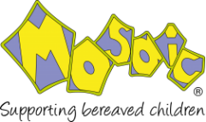
Mosaic is a Dorset based charity which offers trainnig for schools and support for bereaved children in Dorset. If you would like some advice about how best to support a bereaved child or young person, call 01258 837 071 or email info@mosaicfamilysupport.org. Visit their website here.

BBC Ideas - A suite of short films focusing on death, bereavement and grief has been made. They may be useful individually to stimulate discussion. For example there is one where Palliative care doctor and author Kathryn Mannix argues that it's time to break the taboo that exists around death – click here. And another, which centres on how for some, their childhood bereavement has been a source of strength as they have grown up. Click here.

